|  |
| --- |
| (Lorenzo Cafaro/Pixabay, modified by CoinDesk) |
| **Project :Crypto Trend Insights**  **Course: Scientific Data Visualization**  Spring 2023 |
| CSCE 5320 University of North Texas Spring 2023 |



**PROJECT PROPOSAL**

# TEAM-15

|  |  |  |
| --- | --- | --- |
| **NAME** | **EUID** | **MAIL ID** |
| Dowtya Sri Prasanth Vemula | 11618008 | DowtyaSriPrasanthVemula@my.unt.edu |
| Lakshmi Priya Kalapala | 11514003 | Lakshmipriykalapala@my.unt.edu |
| Senthil Kumar Rajendran | 11557086 | SenthilKumarRajendran@my.unt.edu |
| ViswakSenaPalaparthi | 11580431 | viswaksenapalaparthi@my.unt.edu |

# Contents

**Names Page.No**

Project Name & Description: 3

Goal and Objectives 11

Motivation 11

Significance 11

Milestones 11

Objectives 12

Features 12

Domain 13

Data Abstraction 14

Types 14

Attributes 15

Task Abstraction 17

Implementation using tools 18

Premininary Results for Analysis 19

Project Management 28

References 29

## PROJECT NAME & DESCRIPTION

**Project Name**: Cryptocurrency Trend Insights

**Project Description**: This project aims to provide insights into market patterns, volatility, and prospective investment possibilities by studying the most recent cryptocurrency market data. The objective is to clean and pre-process the data to remove any mistakes or missing information, and then to develop a variety of visualizations to aid users in understanding the data and spotting investment opportunities. We attempt to prepare the data for analysis by acquiring the data from openly accessible sources like Kaggle and employing methods like normalization and data type conversion. In order to study the data and find patterns and trends, visualizations such as line charts, scatter plots, and bar charts will be produced. We may also produce interactive visualizations in addition to static ones to enable viewers to engage with the data and do more in-depth analyses. In general, we seek to support users in making educated decisions about their investments and deepen their awareness of the cryptocurrency market by cleaning and preparing the most recent cryptocurrency data and producing meaningful visualizations.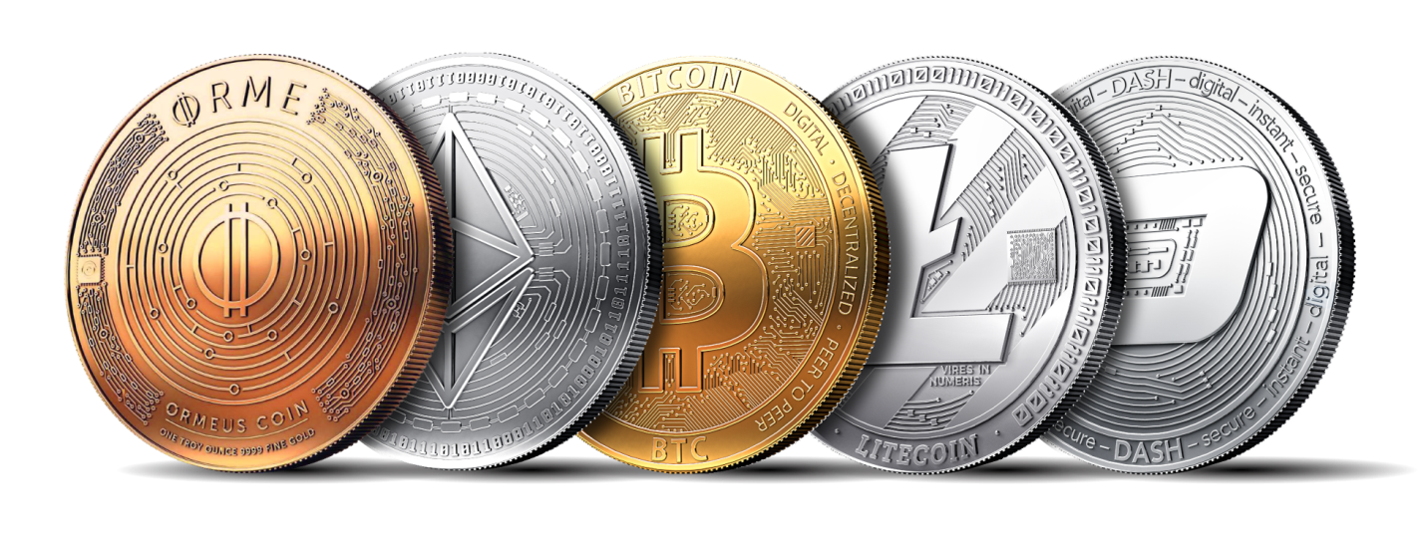

**Chapter1 - Life:**

**Who:**  Investors, traders, cryptocurrency exchanges, and regulators can all be impacted by issues with the bitcoin market.

**What:**  Volatility, security concerns, and regulatory ambiguity are just a few of the obstacles and difficulties the bitcoin market has faced. These issues make it challenging for investors to make wise judgments and may undermine the value and stability of cryptocurrencies.

**Where:** The problems in the cryptocurrency market can occur globally, as cryptocurrencies are traded on various exchanges around the world.

**When:** In Cryptocurrency, the problems in the market can occur at any time because they are dependent on many factors such as economic and technological developments and also on investors.

**Why:** There can be many reasons that can occur in the cryptocurrency market which includes lack of regulation, manipulation of market, Security breaches and hacking and also high volatility which makes it challenging for the investors to make decisions about on their investments.

**How:**

**Volatility**: Because of the tremendous volatility that cryptocurrencies are known for, it is possible for their value to change abruptly and erratically. Several things, including shifts in investor emotion, market speculation, news and events, or technology advancements, might contribute to this.

**Security issues**: A security breach or attack might lead to the theft of bitcoins from cryptocurrency exchanges and wallets. Investors may lose money as a result of this, which also damages market confidence.

**Regulatory uncertainty:**  There is frequently ambiguity on how governments and financial authorities will handle cryptocurrencies because the regulatory environment for them is still evolving. This can make it difficult for investors to evaluate the risks and opportunities of investing in cryptocurrencies.

**Market Manipulation :**Price of the cryptocurrency can be artificially increased by some groups investors for making better profits which we can say that Cryptocurrency markets can be vulnerable to market manipulation. This will directly create a false market for the cryptocurrency and lead to losses for some other investors.

**Technological Challenges:** As the trend of Cryptocurrency and block chain is not that much popular and there are still ongoing challenges with usability, and interoperability. These challenges might impact the usage of cryptocurrencies on long term

**Chapter2 - Data:**

**Who** : We selected the Kaggle dataset of historical cryptocurrency prices for this project. The Cryptocurrency Historical Prices dataset, which is openly accessible on Kaggle, contains historical price information for a number of cryptocurrencies from 2013 to 2021, including Bitcoin, Ethereum, Litecoin, and Ripple.

The open, high, low, and close prices, as well as the volume and market cap, are all included in the daily statistics.

The information was probably gathered from cryptocurrency exchanges or other websites that track the value of cryptocurrencies.

There is no risk of identifying information being revealed because the dataset solely includes data on bitcoin prices and excludes all other types of data.

**What:** The Cryptocurrency Historical Prices dataset from Kaggle records the historical price data for various cryptocurrencies, including Bitcoin, Ethereum, Litecoin, and Ripple. For each cryptocurrency, the dataset includes the following information for each day:

**Date**: The date on which the data was collected

**Open**: The opening price of the cryptocurrency on that day

**High**: The highest price of the cryptocurrency on that day

**Low**: The lowest price of the cryptocurrency on that day

**Close:** The closing price of the cryptocurrency on that day

**Volume:** The trading volume of the cryptocurrency on that day

**Market Cap:** The market capitalization of the cryptocurrency on that day

This data enables for the analysis of trends and patterns in cryptocurrency values through time, as well as the prediction of future prices. Aside from the prices and trading volume of each cryptocurrency on a particular day, the dataset does not record any other events, actions, behaviors, or observations. A few examples of visualizations are shown below:

**Figure 1. Cryptocurrency - Market Cap – Highest (Bitcoin)**

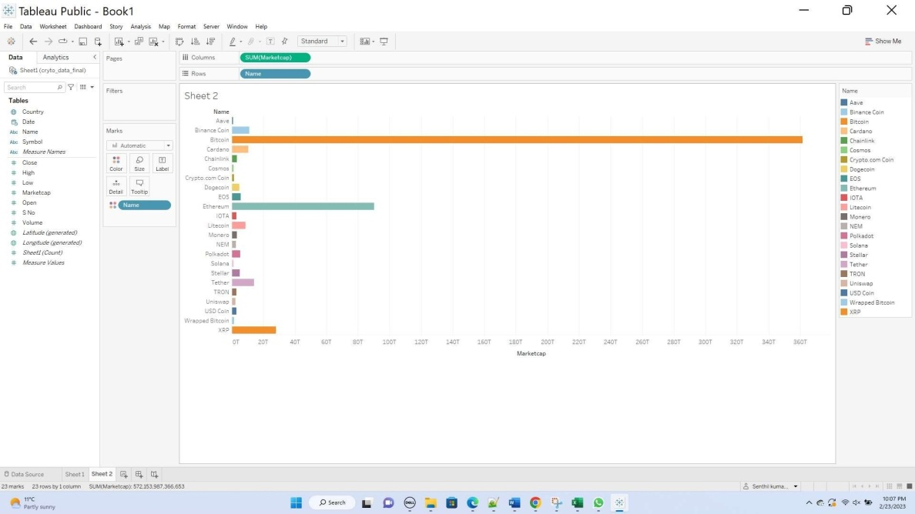

**Figure 2. Cryptocurrency - Market Cap – Lowest (Aave)**

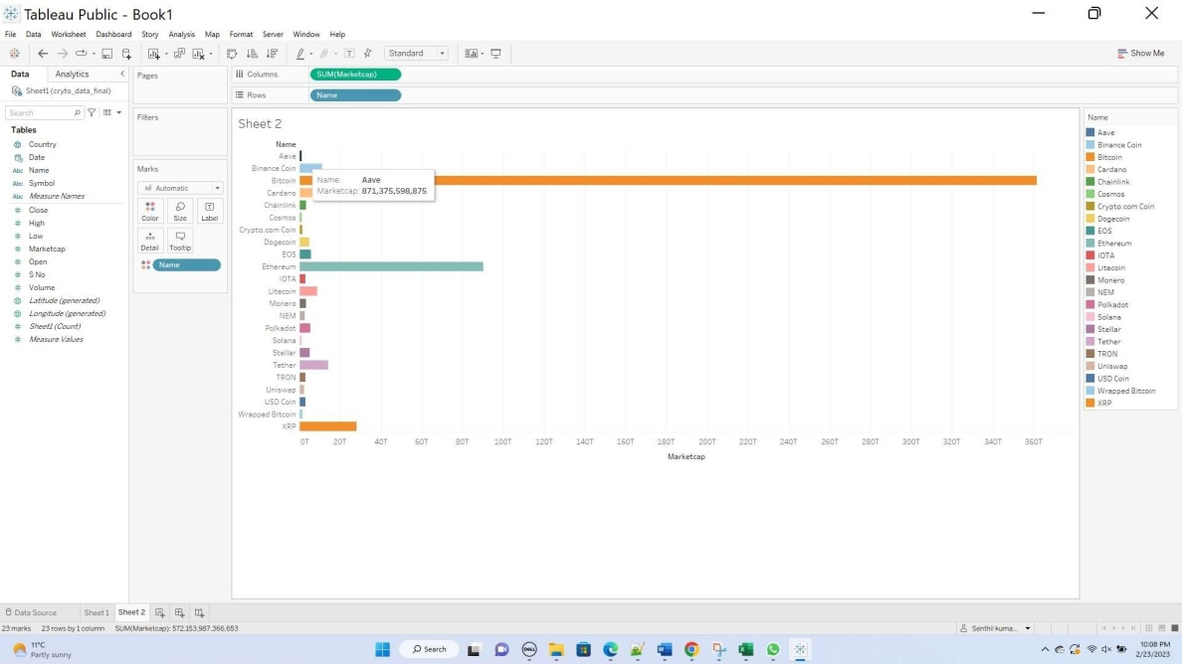

While Figure 1 shows the currencies with highest market share like Bitcoin, Figure 2 displays ones with lowest market cap like Aave that have been captured in the dataset.

**When:** The dataset provides daily historical price data for many cryptocurrencies, including Bitcoin, Ethereum, Ripple, and Litecoin. The data covers from April 2013 to November 2021, implying that the events, actions, behaviors, and observations recorded occurred within this time period.

url need to be added like this :

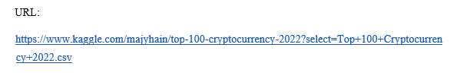

As a result of the data being cross-sectional rather than longitudinal, it was gathered on a daily basis. Because the data shows historical prices rather than current market values, it cannot be considered real-time data. The dataset covers data up through November 2021, which is recent as of February 2023, and this is a key point to remember.

**Where:** All of the data is based on a worldwide scale and is not targeted at any one particular place. When we use "Bitcoin" as the cryptocurrency, for instance, we can view the world's data by highlighting the nations that have a stronger inclination toward the Bitcoin cryptocurrency. This allows us to study the regional differences in interest for a given cryptocurrency.

Figure 3: Bitcoin - Global Interest

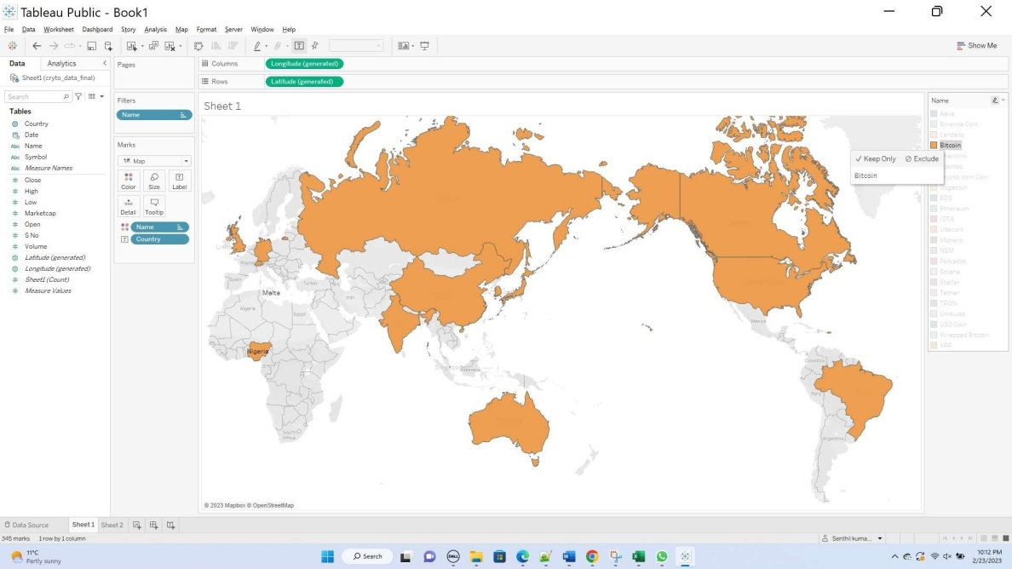

**Why:** Why: The Cryptocurrency Historical Prices dataset can be used to get insights into market trends, volatility, and prospective investment opportunities by evaluating historical price trends for a wide range of key cryptocurrencies. The data can also be utilized to develop data analysis and visualization skills, as well as to aid in cryptocurrency knowledge and adoption.

**Chapter3 - Users:**

**Who:** Though we are targeting the entire crypto investing community? Our major focus is on amateurs who are completely new to the market. This is because they are predominantly the most vulnerable community who can be exploited if not given proper information and insight.

**What:** The application consists of multiple visualizations of the market data that provide the user with insights into all the cryptocurrencies.

**When:** Majorly, we recommend the user to closely follow the visualizations, before making any investment in the market. One could also browse through them daily to follow market trends. This in turn helps one to create a future investment plan.

**Where:** The user can access the visualization on a webpage.

**Why:** The visualizations are useful to the user since he could have better insight into market data and make good judgments while making investments in cryptocurrency. This helps the user to avoid market bubbles and pitfalls.

**How:** The user can note down the best and worst trending currencies by browsing through the visualizations. Then, he/she could work through a filtered list of choices on which the investment seems to have a fair chance. Finally, the user could invest based on the finalized list and budget.

## GOALS & OBJCETIVES

**Motivation:**

Analysing cryptocurrency data can reveal market trends, volatility, and possible investment possibilities because cryptocurrencies are a very young and fast developing market. Data analysis and data visualization abilities can be developed by working with cryptocurrency data, which can be both tough and lucrative. By examining past price trends, trade volumes, and promising new project identification, the data can be leveraged to locate possible investment possibilities. Finally, we can benefit the greater cryptocurrency community and promote the knowledge and use of cryptocurrencies by researching and disseminating insights on data related to cryptocurrencies.

**Significance:**

We seek to empower individuals and organizations to make smarter decisions about purchasing, selling, and investing in cryptocurrencies by offering insights into market patterns and investment opportunities, and by evaluating bitcoin data through user-friendly, multifaceted visualizations.

**Milestones:**

1. Data Acquisition:
   * Obtain the latest cryptocurrency data from publicly available sources like Kaggle.
   * Identify any additional data sources if necessary.
2. Data Cleaning and pre-processing:
   * Clean the obtained data to remove any errors, missing values, or inconsistencies.
   * Pre-process the data using techniques such as normalization and data type conversion.
3. Visualization Design:
   * Identify key insights and patterns to visualize using D3.js on viz hub
   * Design appropriate visualizations such as line charts, scatter plots, and bar charts.
   * Develop interactive visualizations to enhance user engagement and understanding.
4. Webpage Design:
   * Design a user-friendly and visually appealing webpage to host the visualizations.
   * Implement responsive design for optimal viewing on various devices.
   * Ensure the webpage is easily navigable and accessible to a wide range of users.
5. Integration of Visualizations into Webpage:
   * Integrate the designed visualizations into the webpage.
   * Test the functionality and performance of the visualizations within the webpage.
   * Optimize the visualizations for seamless user interaction and loading times.
6. User Testing and Feedback:
   * Conduct user testing to evaluate the effectiveness of the visualizations and the webpage.
   * Gather user feedback and make necessary adjustments to improve the user experience.
7. Project Launch:
   * Launch the completed webpage and visualizations to the public using vizhub
   * Promote the project within the cryptocurrency community and relevant forums.
8. Continuous Updates and Maintenance:
   * Regularly update the project with the latest cryptocurrency data.
   * Monitor user feedback and make any necessary adjustments to maintain the project's relevance and usefulness.
   * Address any technical issues that may arise over time.

**Objectives:**

* Obtain the latest cryptocurrency data from publicly available sources like Kaggle.
* Clean the obtained data to remove any errors, missing values, or inconsistencies.
* Pre-process the data using techniques such as normalization and data type conversion to ensure its suitability for analysis.
* Create a variety of visualizations, including line charts, scatter plots, and bar charts, to explore the data and identify patterns, trends, and potential investment opportunities.
* Develop interactive visualizations to allow users to engage with the data and explore it in more detail, enabling them to make well-informed decisions.
* Present the visualizations in an accessible and user-friendly format, ensuring they are easy to understand and interpret.
* Continuously update the project with the latest cryptocurrency data to maintain its relevance and usefulness.
* Share the project's insights with the broader cryptocurrency community to contribute to the overall understanding and adoption of cryptocurrencies.
* Evaluate the project's effectiveness in helping users make informed investment decisions and adjust the approach as needed based on feedback and user experience.

**Features:**

* + - Web pages that render various insightful visualisations of the top trending cryptocurrencies
    - Color-coded graphical design with user-friendly and readable legends.
    - Appropriate labelling of crypto time series visualizations

# INCREMENT 1

**DOMAIN**

As we all know that the Cryptocurrency is the decentralised mode of currency that is gaining high popularity these days . Off all these cryptocurrencies, Bitcoin was and is the most popular and also many new digital currencies has been introduced in addition to bitcoin to the cryptocurrency market. The goal of these other types of cryptocurrencies were and are to capitalise on the shortcomings with Bitcoin. As we can clearly state that, one can have its own advantages and disadvantages(flaws). These cryptocurrencies does not have any physical form or any structure like other currencies but these can be used through the assistance of peer to peer networks (Blockchain) which acts as the medium of exchange with a decentralised central ledger that maintaining the transactions and acts as the one source of truth.

Cryptocurrency is a digital currency that requires no actual structure, It will depend on the blockchain innovation method( which is used to make it secure and safe) by utilizing Cryptography.

We can directly mention that it as a kind of a wallet through which cash exchanges can be performed in a secure way.

The main rationale of using the bitcoin was to eliminate the central authority of FIAT currency which it was the main issue that is happening in the present world where either the central power or the bank will decide the worth of the currency that we use. This can be done by using Bitcoin with the help of the Block Chain Technology i.e. a rundown of records stored in the form of blocks maintained on a decentralised digital ledger. Further moving deeper into the process, the blocks which are mentioned above will be connected each other by hashing methods and if the rotation need to be performed on one record or a block , there is a need to alter the other blocks or records which eliminates the issue of unauthenticated exchanges of records to the blockchain.

With the help of the digital wallet, an individual can hold a bitcoin or other cryptocurrency. This digital wallet comprises of two sets of keys which can be described as private and public keys. The owner which we are referring as user here, can use this digital wallet to send and get bitcoins for many different types of transactions. For sending the bitcoin the user needs an private key and for receiving the bitcoin the user needs the public key. The most common way of sending and receiving the digital currencies depends on the framework that is associated with the network. Based on the hashing method, they need to perform for exchanges that are being done in an organization that will be done with helping in order to make new bitcoins which means this will directly help

In any case, this course of counterbalancing the expense that occurs in verifying the exchanges with the production of new digital money isn't workable for every single bitcoin that is available out there and also bitcoin mining has known to have environmental issues with huge energy consumption by bitcoin mining server farms and also the associated alarming levels of CO2 emissions have prompted Governments across the world posing severe restrictions and crackdowns on the use of large numbers of these cryptocurrency forms of money in their countries.

In spite of all this Government opposition to cryptocurrencies, there has been major upward trend in cryptocurrency adoption and acceptance across the world by general population looking to it as a path towards global decentralisation of money in general and in a way might lead to era of legal and societal participation and governance using cryptocurrencies.

**BACKGROUND:** As cryptocurrency is currently on going trend in the currency world, so we come up with an idea of creating the crypto trend insights for helping investors to make decisions for the investments which are valuable to them for better investment of their future. Not only for investors, this is for everyone who want to gain in-depth knowledge in the field of crypto currency.

For this we have selected a data set from Kaggle which is containing nearly 10 attributes for different crypto currencies. There are different types of crypto currencies in which some of them are here such BITCOIN which is most popular and the AAVE cryptocurrency which was launched recently in the year 2020 November.

Link for data set : <https://www.kaggle.com/datasets/sudalairajkumar/cryptocurrencypricehistory>

And then we learnt some of the crypto currency trends to dive into deeper about the crypto currency world through different websites such as <https://www.coindesk.com/newsletters/crypto-long-short/> , this helped us to know about the crypto news and the ongoing trends in the crypto world.

**DATA ABSTRACTION**

The main goals of this project is to collect the major cryptocurrency data and then visualize it for providing the better insights of the data. As we are using the time-series data which means we will analyse the trends in the cryptocurrency over a time period, so we here are executing the perception based web based outline. Here the user can see over a time arc various insights of a specific cryptocurrency which makes it better utilization of the channels.

Since the information is gathered powerfully over a period of time, the perception of the information keeps it changing considering the time imagined.

The main target of data abstraction was to identify what kind of data will be used to draw the visualizations which is in fact a very important thing to do by any person who wants to draw a visualization from any kind of data. Because identifying the type of data that will be going to be used in the visualization helps in supporting the actions on that data very easily to get the desired target.

**DATA SET:**

The dataset we have chosen for this project is [1] Cryptocurrency Historical Prices by Sudalai Raj Kumar available for public use on Kaggle

The dataset talks about historical price variations, market capitalization and market volume of the commonly traded cryptocurrencies like Bitcoin, Ethereum, Litecoin and many more. Using this dataset one could predict the future price of these cryptocurrencies, understand which one ones are stable and volatile and make investment decisions wisely.

**TYPES**

A data type is nothing but the type of visualizations. It is the graphical representation of the data using different types like chart, line chart, bar chart, scatter plot, and many more

Here in our project for increment 1, we are using a Line chart for the visualization. As we are using cryptocurrency data and the values are read in the timeline. To evaluate this timeline data as visualization we use a line chart. Example,

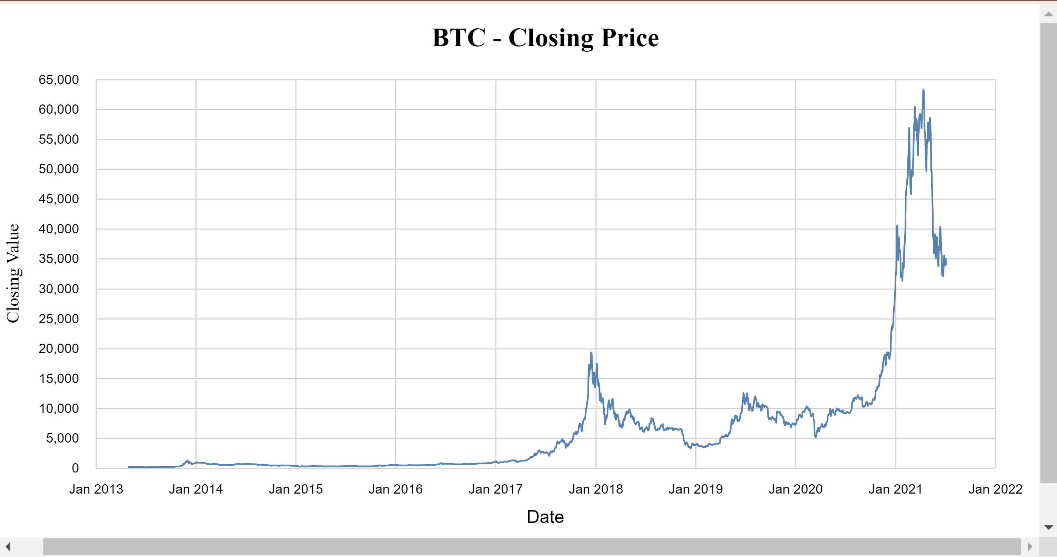

## Fig.:1- Line chart

The above line graph gives the closing price of the cryptocurrency , here we are taking the example of Bitcoin. We are evaluating the closing value of the bitcoin in the month of January each and every year from 2013 to 2022. Considering the closing value on the Y axis and the timeline which is in months (January for the above visualization) on the X axis we are analysing the closing price of the bitcoin. So that, the user can get a brief information about the closing price of Bitcoin in each and every month which helps the user for making decisions.

**ATTRIBUTES**

Attributes are the value description which has the shapes, or the colour, and they can be also measured or logged. It occupies mostly the columns in the data table. Here in this, we are using then raw data , so the below table show the attributes used.

| **ATTRIBUTE** | **DATA TYPE** | **DESCRIPTION** |
| --- | --- | --- |
| Name | string | The name of the cryptocurrency |
| Symbol | string | The symbol or abbreviation representing the cryptocurrency |
| Date | string | The date of the recorded data |
| High | number | The highest price of the cryptocurrency within the given day |
| Low | number | The lowest price of the cryptocurrency within the given day |
| Open | number | The opening price of the cryptocurrency at the start of the day |
| Close | number | The closing price of the cryptocurrency at the end of the day |
| Volume | number | The total trading volume of the cryptocurrency during the given day |
| Market cap | number | The total market capitalization of the cryptocurrency at the end of the day |
| Country | string | The country associated with the specific data entry |

The above shows the attributes. Here we are using mostly the integer, string as the data types. To explain in detail the attributes.

**Name**: It gives the name of the bitcoin

Symbol: It represents the coin symbol either the bitcoin or the Ethereum coin. It represents the coin symbol such as Binance coin’s symbol is BNB, Bitcoin symbol is BTC..

In this way, we have a date, high, low, open , Close , Volume, Market Cap, Country which are related to doing the analysis of the cryptocurrency rate.

**DETAILED DESCRIPTION OF DATASET:**

The dataset contains the data of various cryptocurrencies such as AAVE , BITCOIN, Binance Coin, Ethereum, Litecoin, and Ripple. For each and every crypto there dataset provides the information such as the date, price, open price, high price, low price and trading value which will be helpful in analysing the trends and also helps in making predictions for future decisions.

Cryptocurrencies are the type of a currency that they will use cryptography for the security and the transactions can be verified using many cryptography algorithms. In all of these, Bitcoins was the first known crypto currency, but currently there are thousands of them are in existence.

They can also be used for the digital purchases and the money transfers , for this there will be no need of a bank and also sometimes people makes profits with these. Here we can observe one interesting thing from the above provided dataset is that the prices of them are highly volatile and they will fluctuate within no time i.e. shorter periods of time. This will make them risky for investments because of fluctuations but the fluctuations can also give them the profits on short term investments.

And one more thing we can observe is that from the dataset we can conclude that the trading volume for the cryptocurrencies in the dataset are high during high price which many traders will be active in the trade market for better profit making. On a whole ,understanding this trading volume patterns will help in making profits for the traders.

Overall, the provided dataset given the insights cryptocurrency prices and trading volumes. Ny creating the different visualizations of the data and analysing the data , the investors can take the informed decisions about the trading cryptocurrencies.

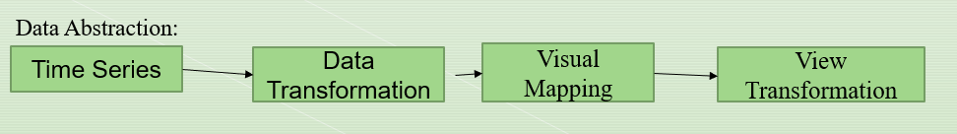

**DATA TRANSFORMATION:**

This process of converting and changing data from one format or structure to another format or structure for the process of data analysis is called Data Transformation. The Data transformation is an important step in Data analysis. Here for the above data set we have used took from the Kaggle website in which we have aggregated data for various cryptocurrencies into one large cryptocurrency dataset and transformed date fields to appropriate format to be used in the visualizations and cleaned and cleaned the data from NAN value.

**TASK ABSTRACTION**

Task abstraction is an important step in making a visualization that is performed after the data abstraction is done on the data coming from the pre-processed data.

Task abstraction plays a crucial role in making visualizations and the task abstraction will be performed after the data abstraction is done. Both Data Abstraction and Task Abstraction need to be performed with utmost attentively for better visualization of the data to avoid repercussions in the future. If these weren’t performed carefully, this might cause ambiguities in the visualization makes it harder for the user to understand the visualization.

When drawing visualizations while the data abstraction is used to identify what is going to be the data for the visualization, the task abstraction is used to identify why we need that visualization i.e., simply identifying the tasks that we are going to perform on the visualization. In task abstraction, many actions can be performed on the abstracted data to get the desired target such as simple action like analyse which can be further divided into two types one is that in the analysing process we consume the data to draw the visualization to discover, neatly present it or simply using the data to make visualizations for fun and the other one is to produce the data that is we annotate the visualizations that we make from the data, record those visualizations or finally derive new kind of data from the existing data. The actions performed can also be of different types like locating or querying the data. All the actions performed mentioned above are either done on all the data or on attributes of the data which will be based on the target of the visualization which can be to identify the trends from the data, outliers in the data or just identifying the features that are present in the data.

**Targets and Actions:**

As we finally got to know what task abstraction is and its importance, we will now discuss the task abstraction that we are going to perform in this project which is a cryptocurrency dashboard.

Following are the data elements that we will be focussing on to achieve our end goal i.e., to provide valuable insights to prospective cryptocurrency investors

**Targets** - Opening Price, Closing Price, High, low

**Actions** - Perform data filtering, aggregation on Opening and closing price to produce daily price fluctuations and Simple Moving Averages of Closing prices across weekly, monthly and quarterly time periods and comparing the effect of opening price on the highest price

**Target** - Market Cap, Volume

**Actions** - Perform filtering, sorting & grouping of market cap data across time and geography and comparing the effect of volumes on market cap and vice versa

As part of increment 2 we have performed all the above actions for multiple cryptocurrencies and have also done correlation of price fluctuations of other cryptocurrencies in relation to price movement of BTC as an additional action

**Task Abstraction Workflow:**

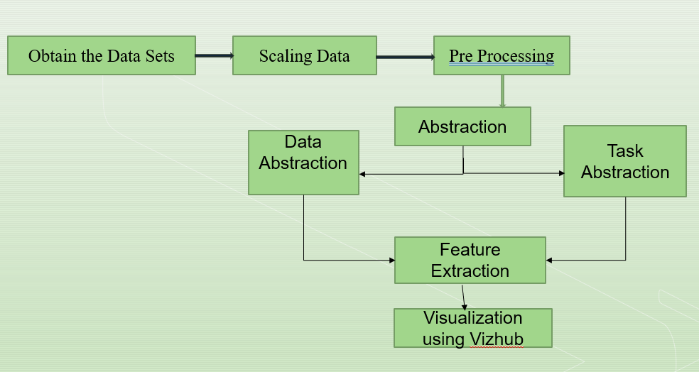

**IMPLEMENTATION USING TOOLS:**

**TABLEAU:**

The first tool that we used in the project implementation is Tableau which is used for visualizing the data through different types of visualizations. Table au is an interactive tool that will be helpful for the organizations for visualizing the dynamic visualizations of the data . With the help of Tableau we created visualizations by importing the file which directly creates visualization without any coding and also it will contain the simple steps creating the visualization. Moreover it’s just like a drag and drop process of creating the visualization.

**D3.js & Vizhub:** And then we used vizhub for creating the visualization charts. Vizhub is an online public platform where the users can create, fork, and share their visualizations to the public. The Visualizations here done are through coding. We used D3.js for creating and developing the charts.D3.js contains functions and objects for making the visualizations. In Viz hub for making charts look better and interactive we have used HTML for developing the webpages and CSS which stands for Cascading Style Sheets for adding styles to the webpage to make it look more attractive. This was all done by using JavaScript for which helps in importing the necessary d3 objects and the functions

**GITHUB:**

And also we used GitHub , which is a website for storing and tracking the projects. In github we will gist the data set and converting it in the form of raw data and the link obtained from the raw data will be given as the source URL for the program in the vizhub which we mentioned earlier. GitHub is mainly used by the developers across the world for keeping track on the projects that they are developing.

**PYTHON:** We used python packages for creating visualizations for correlation of other crypto currencies with the bitcoin. Pandas was used to import the data from csv files to dataframes to leverage the power of pandas to do complex correlation calculations and matplotlib was used for plotting the correlation line chart which compares the price correlation of other currencies namely AAVE, LiteCoin and Murano with respect to BitCoin in Increment 2

**PRELIMINARY RESULTS FOR ANALYSIS**

After performing the Data Abstraction, Task Abstraction then the next step is analysing the results for better insights. Here we are providing different types of visualizations for understanding the trends in the cryptocurrency. We analysed the closing price, Daily fluctuations, opening price vs highest price and many more.

**Visualizations :**



### Fig. 1: visualization for closing price in the month of January from the year 2013- 2022

The closing price line graph visualizes the time series data of the closing price of an asset (in this case, Bitcoin). The x-axis represents the date, and the y-axis represents the closing value. The line smoothly connects the data points, making it easy to see the overall trend in the closing price over time. Visualizing the closing price can help us observe the volatility of the asset. High volatility may indicate higher risks, but it also provides opportunities for profit. A visual representation of the closing price helps us gain a historical perspective on the performance of the asset. Comparing the current price to past performance can provide insights into the asset's potential future behaviour.

Viz hub Link:

<https://vizhub.com/senthilrajendran1/dbc024977907462aae019d637ac0e1f7>

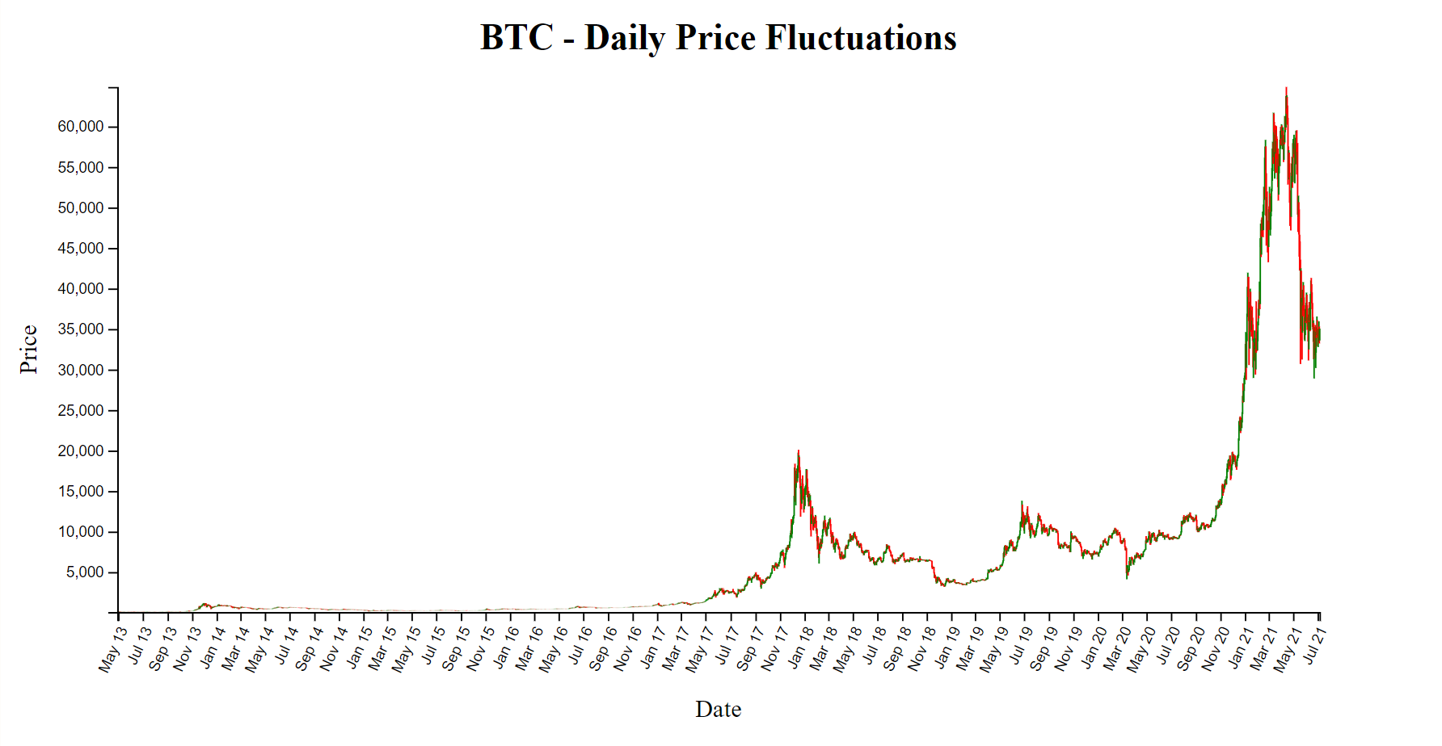

### Fig. 2: Visualization for Daily Price Fluctuations (Bitcoin)

We have developed the candle stick chart that contains the daily price fluctuations of the Bitcoin. On the X axis we had months from May 2013 to July 2021 and in the Y axis there is the price that is starting from 5000 which is going up to 60000 with 5000 difference per each interval. Here in the above visualization we can observe that in the initial years there is not that much spike in the price of the bitcoin and suddenly in the year July 2017 there is a surge in the daily price of the bitcoin and then later after in the first month of 2018 it started decreasing and this continued till Nov 2020 and then the graph suddenly rose. Coming to this type of visualization , candlestick charts are visually effective when it comes to this type of the data as we can see that the users can easily interpret the data and this also allows the users to quickly grasp the complex data for making better decisions.

Viz hub link : <https://vizhub.com/senthilrajendran1/50ada4a85213420091223b84c2e32d3c>

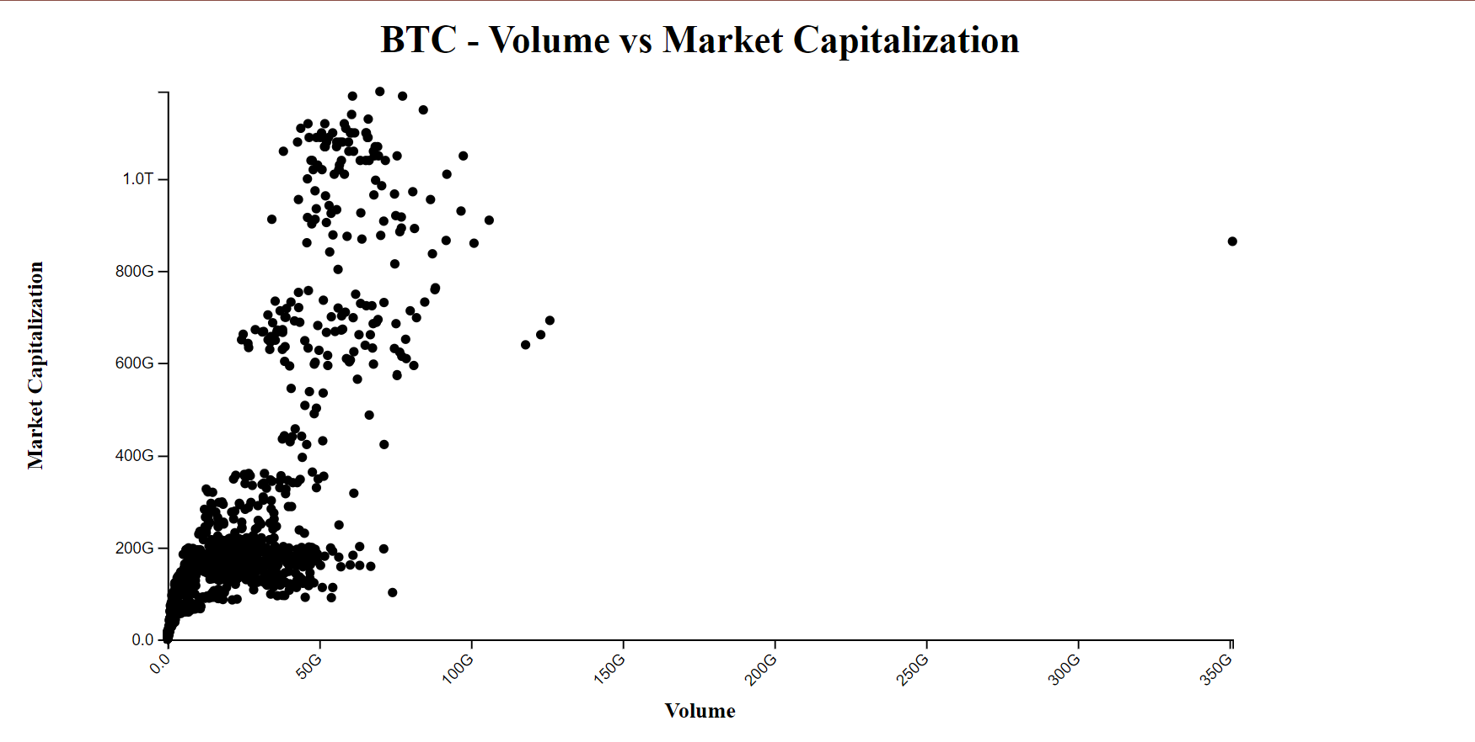

### Fig. 3: Visualization of scatter plot for Volume vs Market Cap

Here in the above visualization a scatter plot between the Volume and [2] Market Capitalization which will provide better explanation between the trading activity and the size of asset in the current market. Moreover, this helps in identifying the relations and the patterns that are helpful in making the decision for the investments. The market capitalization is in the Y axis and the Volume is in the X axis , moving further the Market Capitalization is having the highest more that 1.0 T starting from 0 and divided by 200G each and the volume is up to 350G which is divided by 50G per interval. By overserving the above visualization we can conclude that as the volume is increasing the market capitalization also starts increasing. On a whole we can say that this scatter plot will helps in analysing the relation between the Volume and the Market capitalisation for providing the insights that helps in making informed decisions about future investments.

Viz hub link:

<https://vizhub.com/senthilrajendran1/18af108995544813842ad21b2f862fa2>

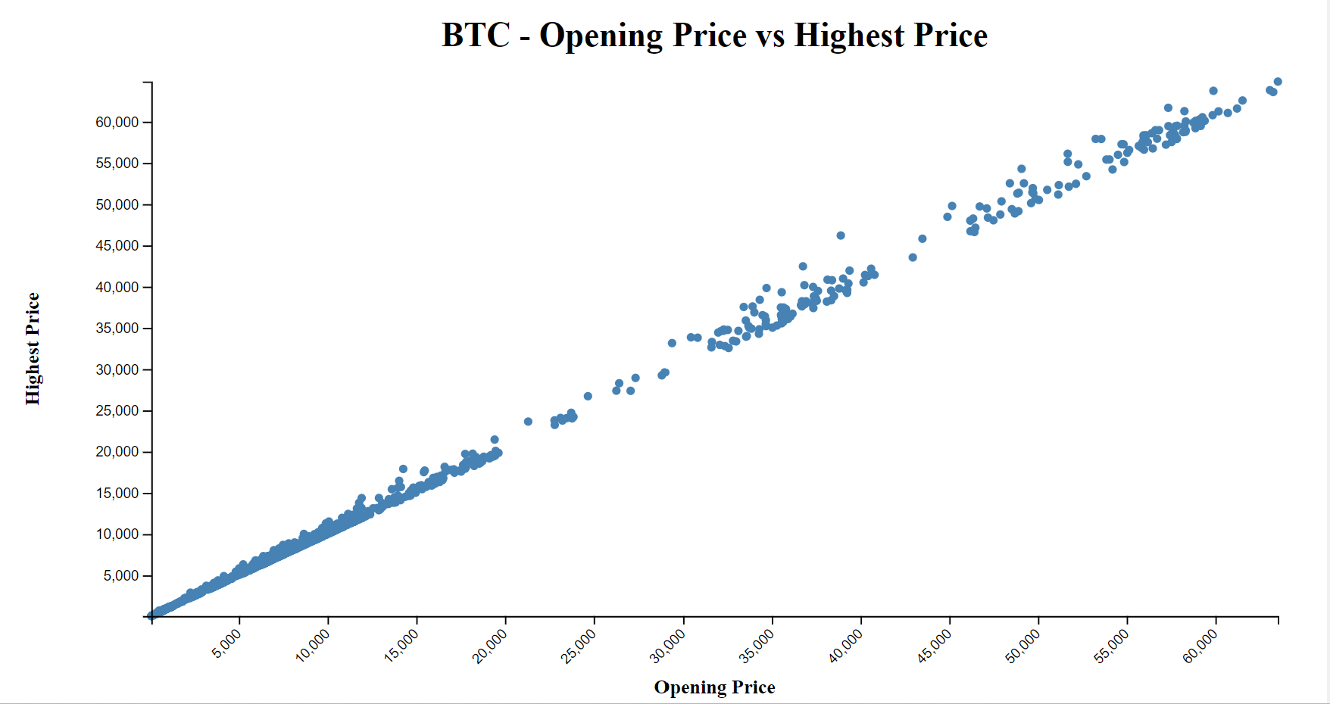

**Fig. 4: Visualization of scatter plot for Opening Price vs Highest Price**

This visualization describes a scatterplot between the Opening Price and the Highest Price which helps to reveal the bitcoin opening price i.e. which is the starting of the trade and the highest price which the trade reaches the highest price during the period(mentioned time line) . Here in the X axis we had the opening price and on the Y axis we had the highest price . The x is starting with the price of 5000 and ends with 60000 which is divided by 5000 each per interval and this is the same case for the Y axis too where the highest is 60000 and the lowest is 5000. As the dataset is large we can see that the highest price and the opening price has gone more than 60000.

In summary, a scatter plot between Opening Price and Highest Price can help visualize the relationship between the initial trading price of an asset and the highest price it reaches during a specific period. It can provide insights into [3] correlation, price volatility, trends, outliers, and intraday price patterns, which can be valuable for understanding an asset's behaviour and making informed trading decisions.

Vizhub link: <https://vizhub.com/senthilrajendran1/738b22ce97aa479d9ec1879a20d6623>f

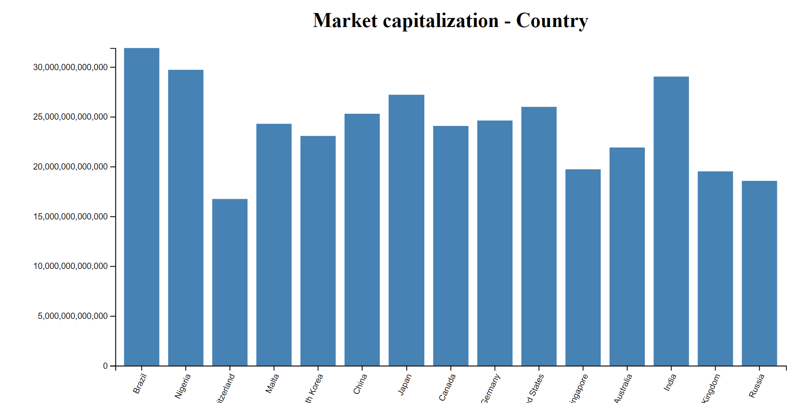

## Fig. 5: Visualization of Bar Graph for Market Capitalization -

The above visualization shows a bar graph showing the market capitalization per country which will help to analyse the wealth across different countries all over the world. Here by visualizing the market capitalization in the form of a bar graph , we can easily compare the trends, size of the markets and we can understand the financial investments. So this is the main reason of using the bar graph for representing the market capitalization per country . As we all know that bar graph contains rectangular bars that will help to compare easily here we are comparing the countries and moreover the bar graph will also give ranking by comparing the ranks of the countries according to the order either in ascending order or descending order. And also bar graph will helps us to analyse the trends too. Here as we can see in the X axis we had countries and in the y axis we had Market capitalization. Currently, in the above bar graph we can see that Brazil has the highest Market capitalization more that 30,000,000,000,000 and Switzerland has the lowest market capitalization roughly above 15,000,000,000,000 and below 20,000,000,000,000.

On a whole we can summarize that the barograph showing market capitalization per country can efficiently help in visualizing the wealth of different countries across the world and it helps for easy comparison , and identification of the trends.

Vizhub link : <https://vizhub.com/senthilrajendran1/6518849b8f26493ea5c6bc525742501c>

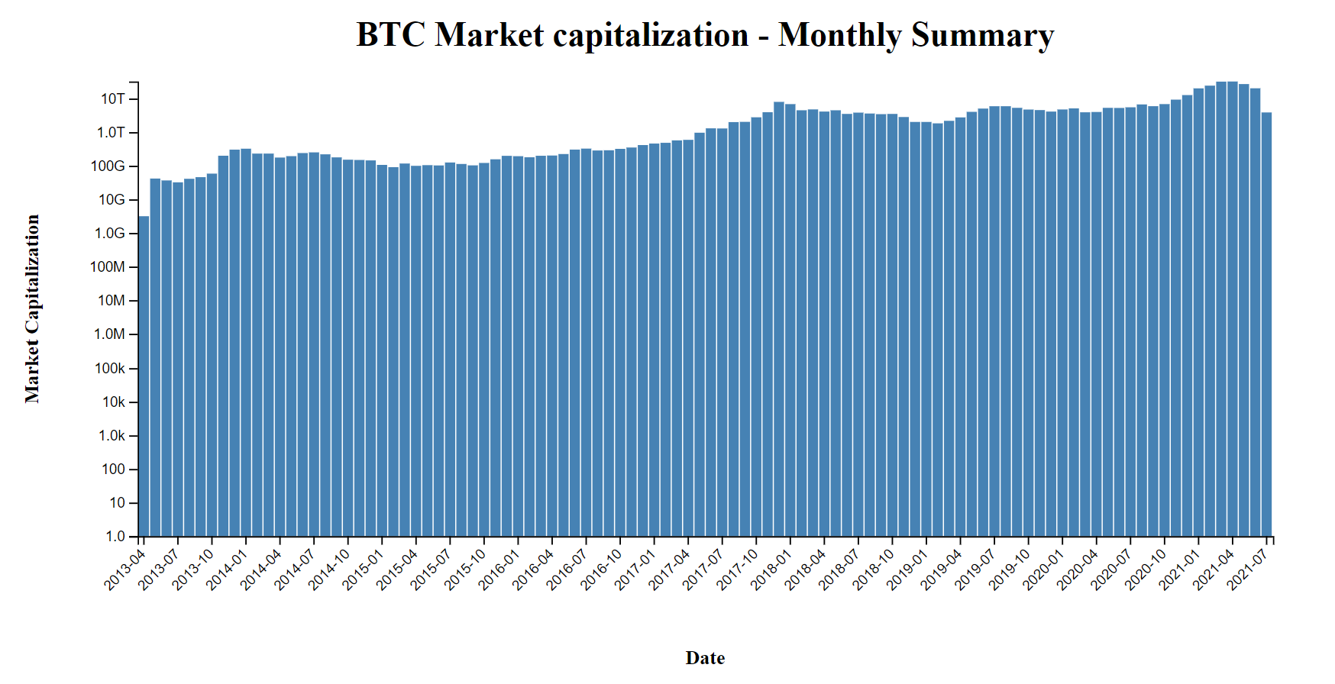

## Fig. 6: Bitcoin Market Capitalization- Monthly summary

The Fig 6 represents the bar graph showing the market capitalization of the bitcoin across months and this will help to visualize the market value of the bitcoin. This bar graph helps to identify the patterns that will show the slight increase or if there may be the slight decrease in the Market Capitalization. The main reason for using the bar graph here is that it helps for easy comparison among the Market Capitalizations . Here in the X axis we had date(months) and on the Y axis we had Market capitalization. The date is divided for 3 months for each interval starting from April month of 2013 and ends with July of 2021 and on the Y axis we had Market capitalization which are being increased into 10 times such 1 in this interval and then 10 in the next interval. The highest is on the year 2022 of month April which is nearly 10 T and the lowest is nearly 5 G in the month of April 2013. On a whole this bar graph showing the market capitalization across the time over years helping the user/ investor to better understand the data by visualizing it better. This makes the user to take decisions.

Vizhub link: <https://vizhub.com/senthilrajendran1/1f8a255c8ad7455baffdda0d41231097>

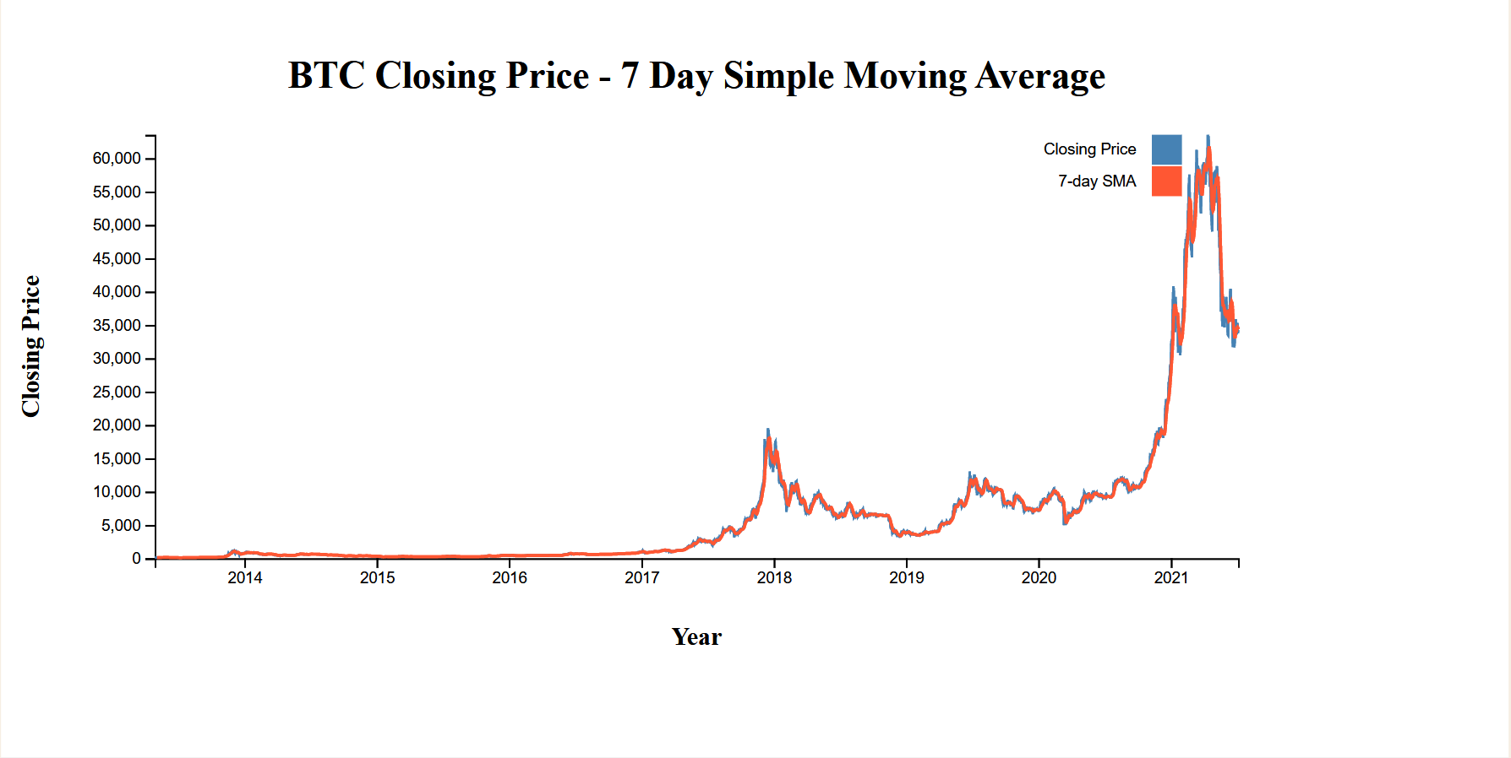

## Fig. 7: Bitcoin Closing Price – 7 day Simple Moving Average

Fig .6 shows the visualization of the Bitcoin closing price on a 7 day simple moving average and this line chart contains Year on the X axis starting from 2014 and ending with 2021 with 1 year difference for each interval and then on the Y axis it contains the Closing Price of the Bitcoin, the starting price is 0 and the ending price is 60000 with a regular interval. The 7 day SMA is represented in red colour line and the closing price is represented by a blue colour line. Moving further the highest value is nearly more than 60000 in the year 2021 and the lowest value is 0 in the initial years which is from 2014 to 2017 and the graph spikes after the year 2017. The graph again then dipped in the year 2018 and again after rose constantly reached highest in the year 2021.

Here in the above visualization we are visualizing the SMA(7 days) of the bitcoin, this is more sensitive which the user investor can identify the sudden changes that had occurred recently so that they can make informed decisions in their trading. This will directly help the short term traders, so that they can gain benefits in understanding the complex data through this visualization. However, this might cause repercussions some times because due to its sensitivity because of short term.

Vizhub link : <https://vizhub.com/senthilrajendran1/ad9155df6f044b608f56f79b996a3ea5>

## Fig. 8: Bitcoin Closing Price – 30 day Simple Moving Average

Fig .8 shows the visualization of the Bitcoin closing price on a 30 day simple moving average and this line chart contains Year on the X axis starting from 2014 and ending with 2021 with 1 year difference for each interval and then on the Y axis it contains the Closing Price of the Bitcoin, the starting price is 0 and the ending price is 60000 with a regular interval. The green line representing the 30 day SMA and the blue line representing the closing price same as mentioned in the above SMA. Similar to the above graph the SMA ( monthly ) as in the SMA ( 7 Days) , the graph is low in the initial years and then suddenly started increasing from the year 2017 which raised to 20,000 and then dipped again. And again in the year 2019 it started increasing , with some fluctuations it went to highest in 2021. Moving further a bit deeper, this is the better overall trend than the 7 day SMA . The main reason for that is it will be less sensitive to the short time changes or fluctuations of the prices ,as we are comparing this monthly rather than weekly. This will also help the swing traders who are looking to hold the currencies for weeks to a month. Moreover, this will also help to filter out some of the noisy data and gives clear understanding of the prices for making decisions.

Vizhub link : <https://vizhub.com/senthilrajendran1/b35fe0ead5484efe932d299c91a92f7b>

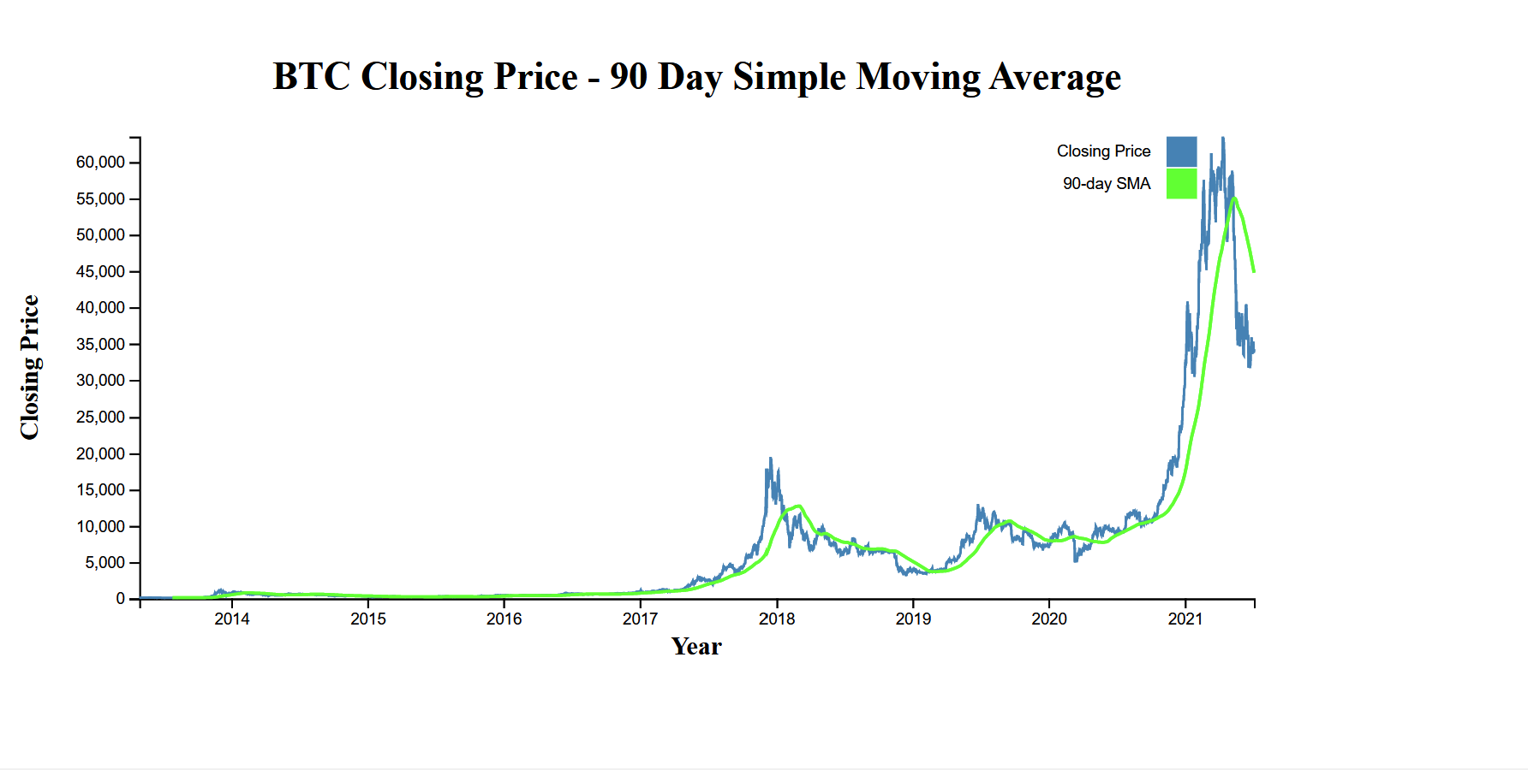

## Fig. 9: Bitcoin Closing Price – 90 day Simple Moving Average

Fig .9 shows the visualization of the Bitcoin closing price on a 90 day simple moving average and this line chart contains Year on the X axis starting from 2014 and ending with 2021 with 1 year difference for each interval and then on the Y axis it contains the Closing Price of the Bitcoin, the starting price is 0 and the ending price is 60000 with a regular interval. The green line represents the 90 day SMA and the blue line represents the is the closing price. When compared with the other SMA’s above which are Weekly and monthly , there is a slight change in the SMA where the SMA is lesser than the closing price. And this 90 day SMA captures the long term price of BTC . This 90 day SMA is least sensitive to daily price fluctuations among the SMA”s we have done here. This particular SMA is very useful to the long term investors who wish to understand the overall market and the fluctuations of all the prices and this makes the investors to make decisions . This will also serve as a support or resistance level, for understanding the trends on an average.

Vizhub link: <https://vizhub.com/senthilrajendran1/b5f70819cdea4592836b08c6c4638b02>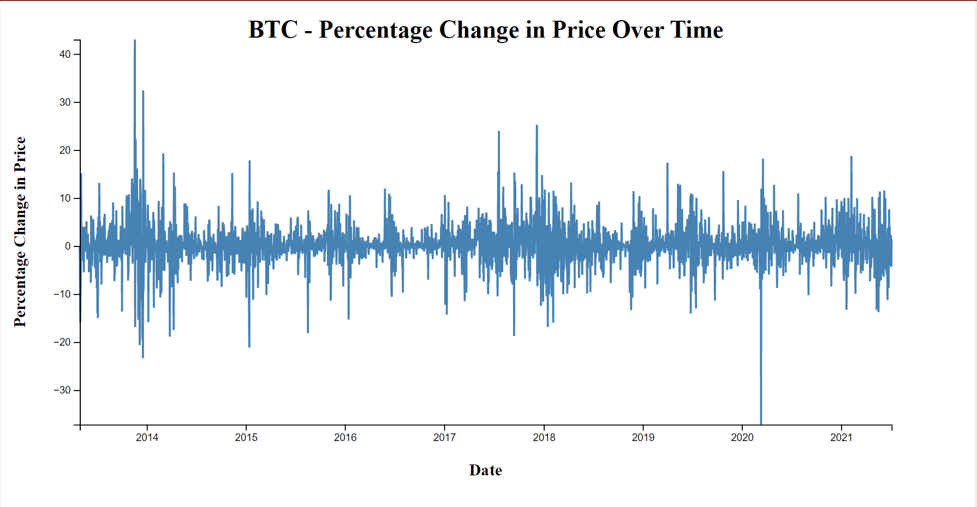

## Fig. 10: Bitcoin Percentage Change in price over time

The above visualization shows Percentage Change in price over time of the Bitcoin, in the X axis we had years from 2014 to 2021 and on the Y axis we had values ranging from -30 to +40.

Visualizing of the chart showing the percentage of change in price over time will provide the better insights of price of the bitcoin and also it will give the historical performance. Moreover, this visualization helps in understanding the market trends and this will also further helps in identifying volatility which means the price swings over periods. Although, the periods which are high volatile may give opportunities for the short term traders but these insights can be used by long term investors to assess the risks that might cause in the future if they invest in the particular currency. And also, by observing this the investors can measure the effectiveness of their investment strategies. Analysing this, the investors can make predictions and make informed price decisions for future investments.

Vizhub link : <https://vizhub.com/senthilrajendran1/9c0c6b4a34134ef58e0d8d5a16c66d09>

Increment 2

In Increment 2 we have focussed on implementing all the tasks described in increment 1 for multiple cryptocurrencies. We have worked to make code changes to every visualisation task to create reusable functions to work for multiple currencies namely AAVE, LiteCoin and Murano in addition to BitCoin, so as to minimise the number of code files and also learn how to code effectively and efficiently. Following this brief introduction will be a sample screens of all the visualisations.

**Opening price vs Highest price**

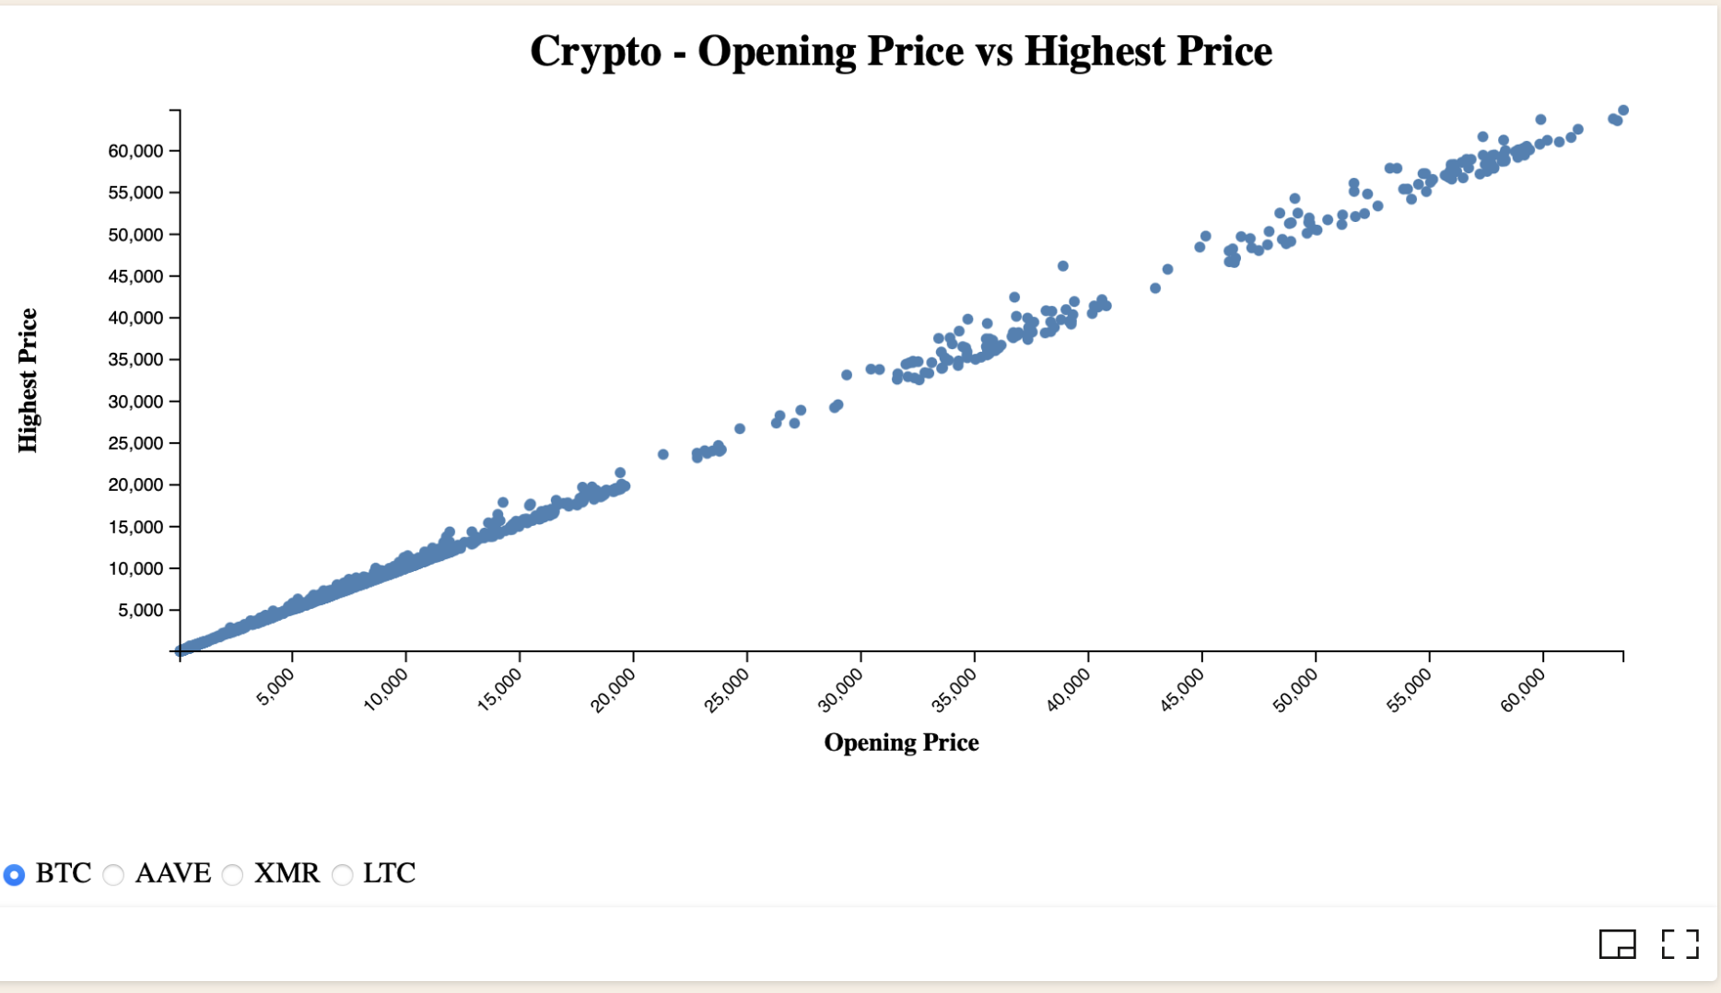

## Fig. 11: Opening price vs the closing price of Bitcoin

The above visualization shows the opening and the closing price of the bitcoin in the form of a scatter plot and where the opening price in on the X axis and the closing price is on the Y axis.

The X axis contains the values from 5000 to 60000 with the intervals of 5000 and the y axis which is the closing price is containing the values same from 5000 to 60000 with a interval of 5000 each. Moreover on a whole we can observe from the graph there opening price is nearly same as the closing price.

Visualizing of the chart showing the highest price vs the opening price will provide the better insights of price of the bitcoin and also it will give the historical performance. And also this visualization helps in understanding the opening price trends and this will also help the investors in the beginning of their trading that which they can proceed with the bitcoin or not? i.e. they can invest in the bitcoin or not. There is a radio button which is provided here so that the user can use that button for different cryptocurrencies.

Vizhub link : <https://vizhub.com/senthilrajendran1/738b22ce97aa479d9ec1879a20d6623f>

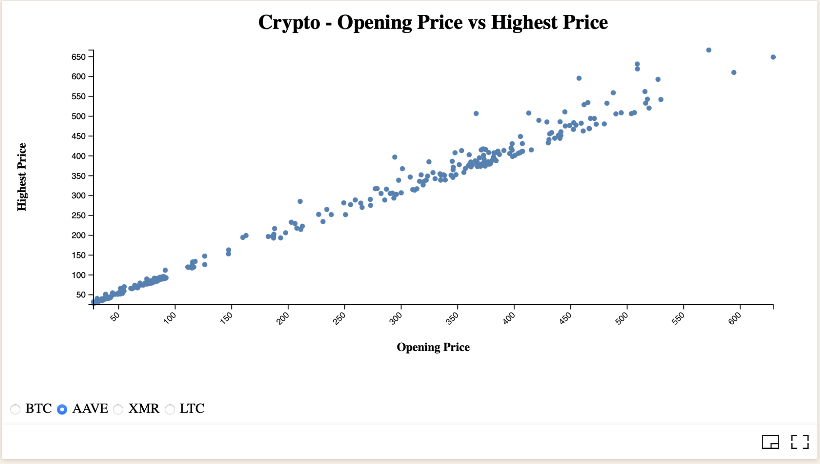

## Fig. 12: Opening price vs the closing price of AAVE

The above scatter plot helps us in understand the trends of the opening price and the highest price of the AAVE cryptocurrency, by visualization of this scatter plot the investor can understand that the AAVE currency is not that much popular when compared with the bitcoin and also the investor can directly compare this with using the radio button provided here. The X axis contains the values from 50 to 600 with the intervals of 50 and the y axis which is the closing price is containing the values same from 50 to 650 with a interval of 50 each. The price of the AAVE cryptocurrency has been being increased slowly with the slight surge observed in a timely manner. And also AAVE cryptocurrency is not that much costly as compared with the cost of the Bitcoin we can directly say that Bit coin is nearly 10 – 100 times more than the AAVE currency. With this the investor can make decisions to invest in that or not.

Vizhub link: <https://vizhub.com/senthilrajendran1/738b22ce97aa479d9ec1879a20d6623f>

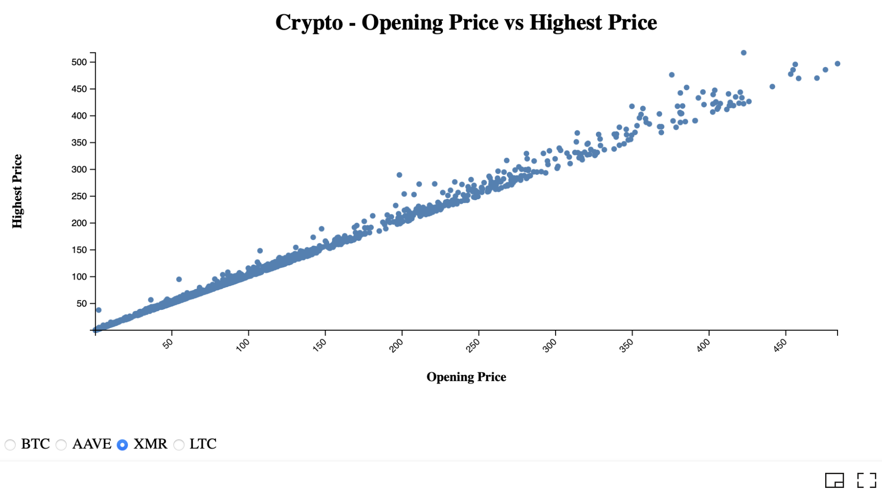

## Fig. 13: Opening price vs the closing price of XMR

Fig .13 shows the visualization of the XMR highest price vs the opening price and this scatter plot contains opening price on the X axis with 50 difference for each interval and then on the Y axis it contains the Highest Price of the XMR, the starting with 50 and the ending price is 500 with a regular interval of 50 and the X axis starts with 50 and ends with 450 this is same nearly as the AAVE cryptocurrency , this is also not that much popular and this will also having the lesser prices compared with the bitcoin.

The highest opening price is more than 450 and the highest price nearly more than 500. This will help the investors to make decisions in investing in this cryptocurrency or not.

Vizhub link : <https://vizhub.com/senthilrajendran1/738b22ce97aa479d9ec1879a20d6623f>

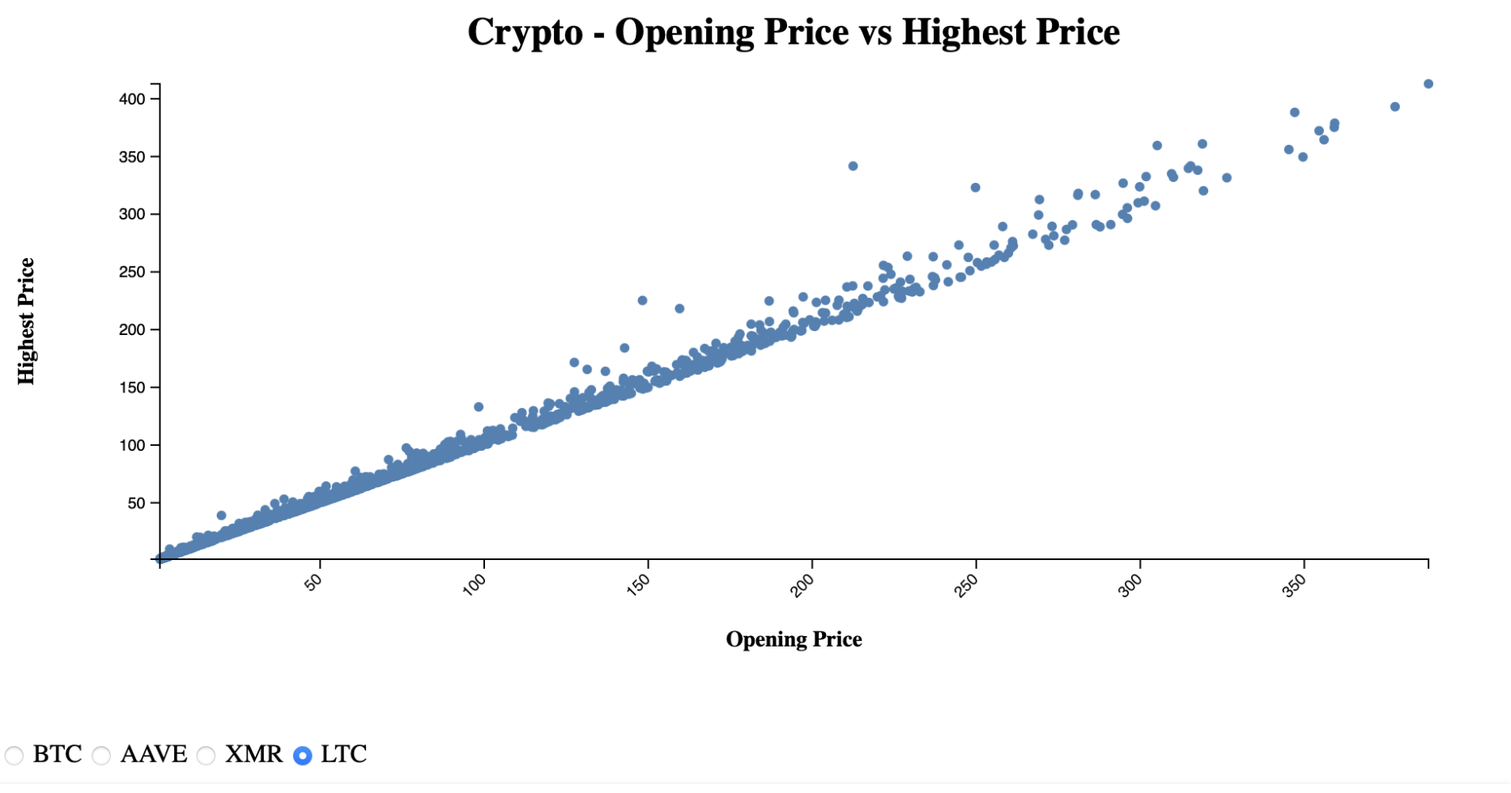

## Fig. 14: Opening price vs the closing price of LTC

As detailed in the same graphs above this will also help for visualizing the crypto trends of the LTC cryptocurrency, if the investors knows the opening price and the highest price of the cryptocurrency then he/she can start making the decisions in their trading. Same as the other graphs this is also containing the opening price on X axis and closing price on y axis.

Inclusion of a radio button for different cryptocurrencies will help the investor to directly compare the prices of the cryptocurrency which are opening and highest prices that which the investor can start taking decisions. Here the investors can directly understand that Bitcoin has the highest opening price and the highest price, so this insight will help the investor to take the decisions.

Vizhub link : <https://vizhub.com/senthilrajendran1/738b22ce97aa479d9ec1879a20d6623f>

Task : Crypto Market Capitalization

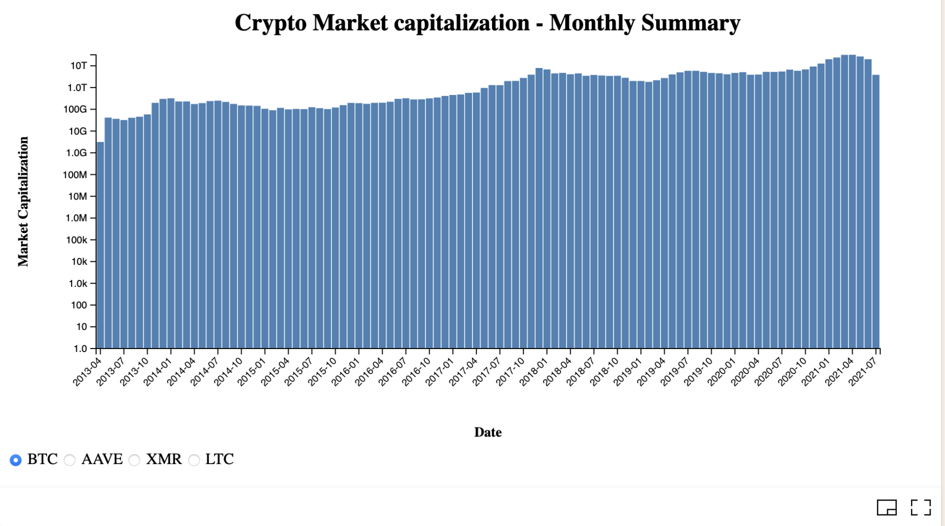

## Fig. 15: Market capitalization of Cryptocurrency (Bitcoin)

For bitcoin: The market capitalization bar graph visualizes the time series data of the market capitalization of an asset (in this case, Bitcoin). The x-axis represents the date, and the y-axis represents the market Capitalization. The bar graphs helps in understanding the trends in which the x axis which is in months with the intervals of 3 months from the years 2013 April to 2021 July and in the y axis it is the capitalization with 1.0 to 10T which is growing exponentially, although there are ups and downs in the graph , this can help in understanding the market capitalisation of the bitcoin. It initially started with above 1.0 G and ended with 100G in 2014 January and the April months and there are some fluctuations, and after the graph(capitalization) gone to 1.0 T and more than that in the years of 2017 and 2018 and the highest is observed in the initial months of 2021 from January to April which the graph touched to 10T and fell down to 100 G again in the month of July 2021.

The people who are investing will want to know the market cap as a way to measure the size of the cryptocurrency in terms of a value comparing with other cryptocurrencies. A cryptocurrency with larger cap will indicates that it is more established currency and on the other hand smaller cap will indicate that it might be risky to invest in that.

Vizhub link: <https://vizhub.com/senthilrajendran1/1f8a255c8ad7455baffdda0d41231097>

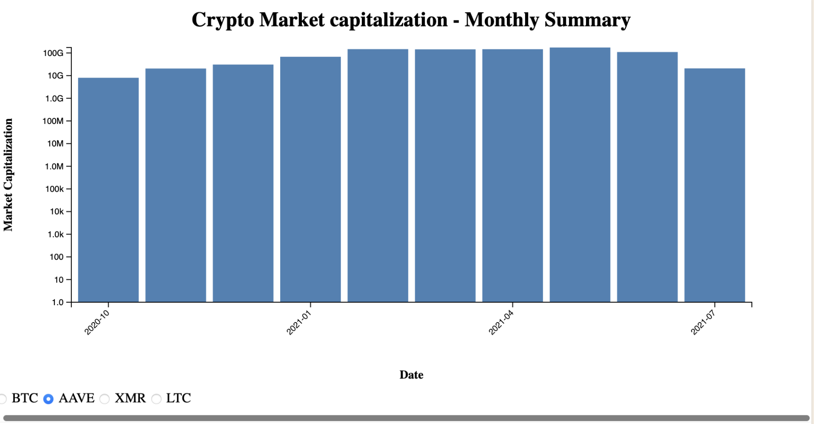

## Fig. 16: Market capitalization of Cryptocurrency (AAVE)

The x-axis represents the date, and the y-axis represents the market Capitalization

For AAVE cryptocurrency we can conclude that there is no much popularity and this has the highest market cap that has gotten recently , in the last 2 years which is from the year 2020 as it was introduced in the year 2020.Initially it is 10G and then it’s consistent and there are much fluctuations that there is an increase from 10G to 100 G in months, In the month of the October 2020, its nearly 10G and in starts consistently increasing and the graph rose to 100G in the month of February in 2021, and then it consistently maintained that cap but its decreased to 10G in the July of 2021, this does not happened at a time , this decreased gradually. As we cannot conclude that there is no sudden dip in the graph, the investors can think on investing the AAVE cryptocurrency based on the trends.

Vizhub link : <https://vizhub.com/senthilrajendran1/1f8a255c8ad7455baffdda0d41231097>

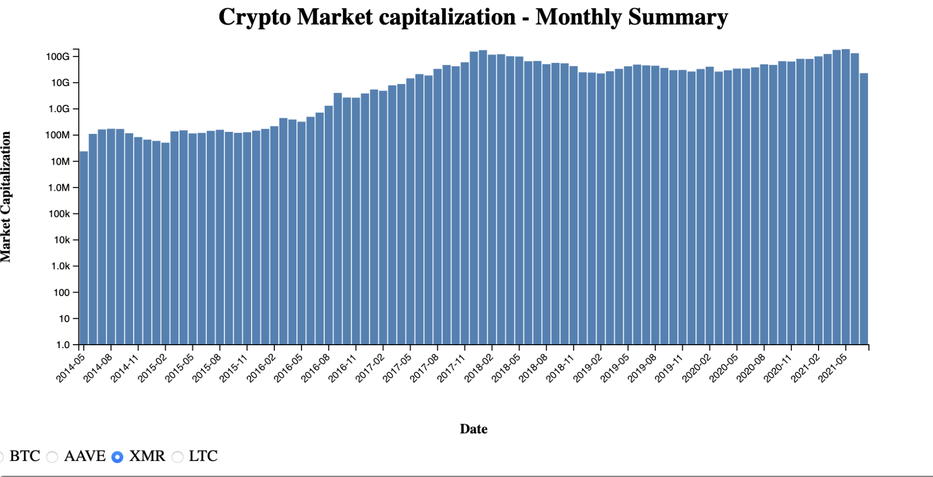

## Fig. 17: Market capitalization of Cryptocurrency (Monero)

The x-axis represents the date, and the y-axis represents the market Capitalization

For XMR cryptocurrency the investor can make an assumption that it is having the popularity and also that the popularity has been increased in the last 10 years, In 2014 its nearly 10M and in 2021 its gone to nearly 100G. However, we can see some fluctuations in the graph, which the graph has an incline from the year 2014 to 2018 which the highest values reached to 100G in the year 2018 and then there is a dip which it nearly fallen down to 60 G and after that it again consistently has the same market cap and then again rose nearly to 100 G in the month of May 2021. The investor can think of making investment in this cryptocurrency as there is no sudden dip or sudden change in the graph. Inclusion of radio button which will help the investor to select the cryptocurrency that he/she want to compare the market cap at a time without moving to other page.

Vizhub link: <https://vizhub.com/senthilrajendran1/1f8a255c8ad7455baffdda0d41231097>

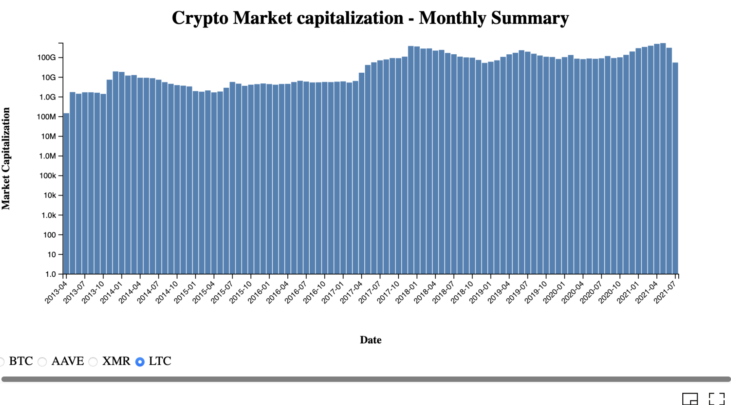

## Fig. 18: Market capitalization of Cryptocurrency (LTC)

For LTC Cryptocurrency : This above bargraph helps in visualizing the trends of the market cap for the LTC cryptocurrency. The x-axis represents the date, and the y-axis represents the market Capitalization. This bar graph helps in understanding the trends in which the x axis which is in months with the intervals of 3 months from the years 2013 April to 2021 July and in the y axis it is the capitalization with 1.0 to 100G which is growing exponentially, there are ups and downs in the graph , when the investors starts observing the visualization he/she can get a clear idea that the there might be a risk of investing in this cryptocurrency , as we can see that in the year of 2013 it is nearly 100M and then it rose and fell down in the year 2014 April and it is consistent till July of 2015 and then maintained a consistency till January of 2018 and then again fell down and rose in 2019 January and rose till may of 2019 and then fell down. Although there is some consistent but on a whole this is not consistent. So this will help the investor to take decision that it might be inconsistent if investment is done in this cryptocurrency.

Vizhub link : <https://vizhub.com/senthilrajendran1/1f8a255c8ad7455baffdda0d41231097>

Task: Crypto Closing Price WE have described about the bitcoin in the Increment 1

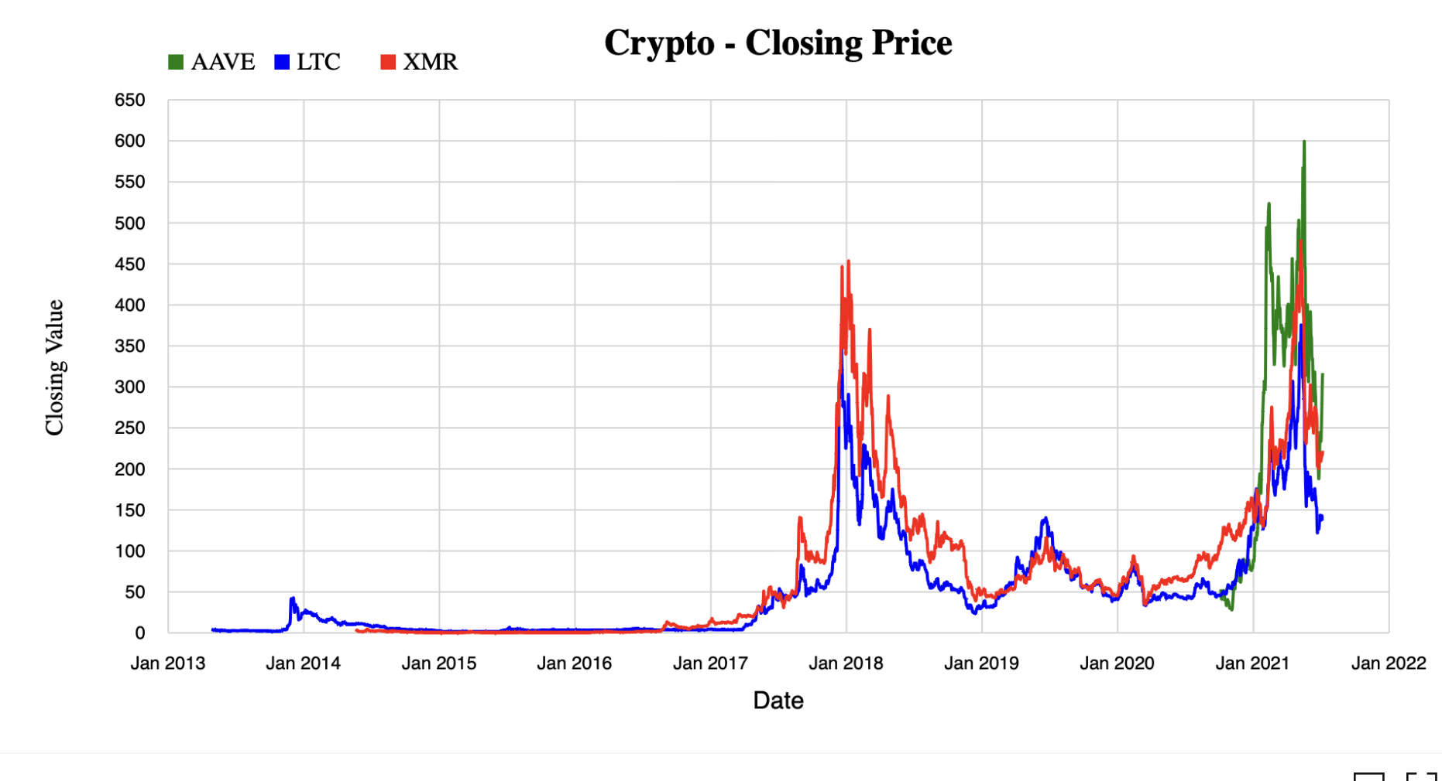

## Fig. 19: Closing price of the Cryptocurrencies( AAVE, LTC, XMR)

The closing price line graph visualizes the time series data of the closing price of an asset (in this case, we have used multiple line chart where there are different line charts displayed for different crypto currencies based on three colours given to them. Totally there are 3 different cryptocurrencies compared in this chart which are AAVE, LTC and XMR . The x-axis represents the date which is the January month of the year from January 2013 to January 2022, and the y-axis represents the closing value which is from 0 to 650 and divided with a regular intervals of 50 each.

The blue colour line represents the cryptocurrency LTC which is 0 in the year 2013 and then started increasing gradually from 2017 which it means gained popularity in the year 2017 and moving further the red line representing the cryptocurrency XMR which started in middle of 2014 and the graph is in 0 for nearly 2 years and then the rise in the line happened in the year 2016.Both the currencies rose to the highest of 300 and 450 in the year 2018 before the release of the AAVE and then the AAVE released after JAN 2020 there is a rise in all the cryptocurrencies after January 2021 which the LTC is having the highest with 350 above nearly 370 and the AAVE has the price of 600 and XMR with a price of 490. Therefore the investor can conclude that the AAVE has gained a lot much popularity after its launch and the investor can make a decision to invest on AAVE by taking this graph into consideration

Vizhub link : <https://vizhub.com/senthilrajendran1/fca6e6c3e27a454991918926a6bb4d13>

Task : Volume vs market Capitalization WE have discussed about the bitcoin in the Increment 1

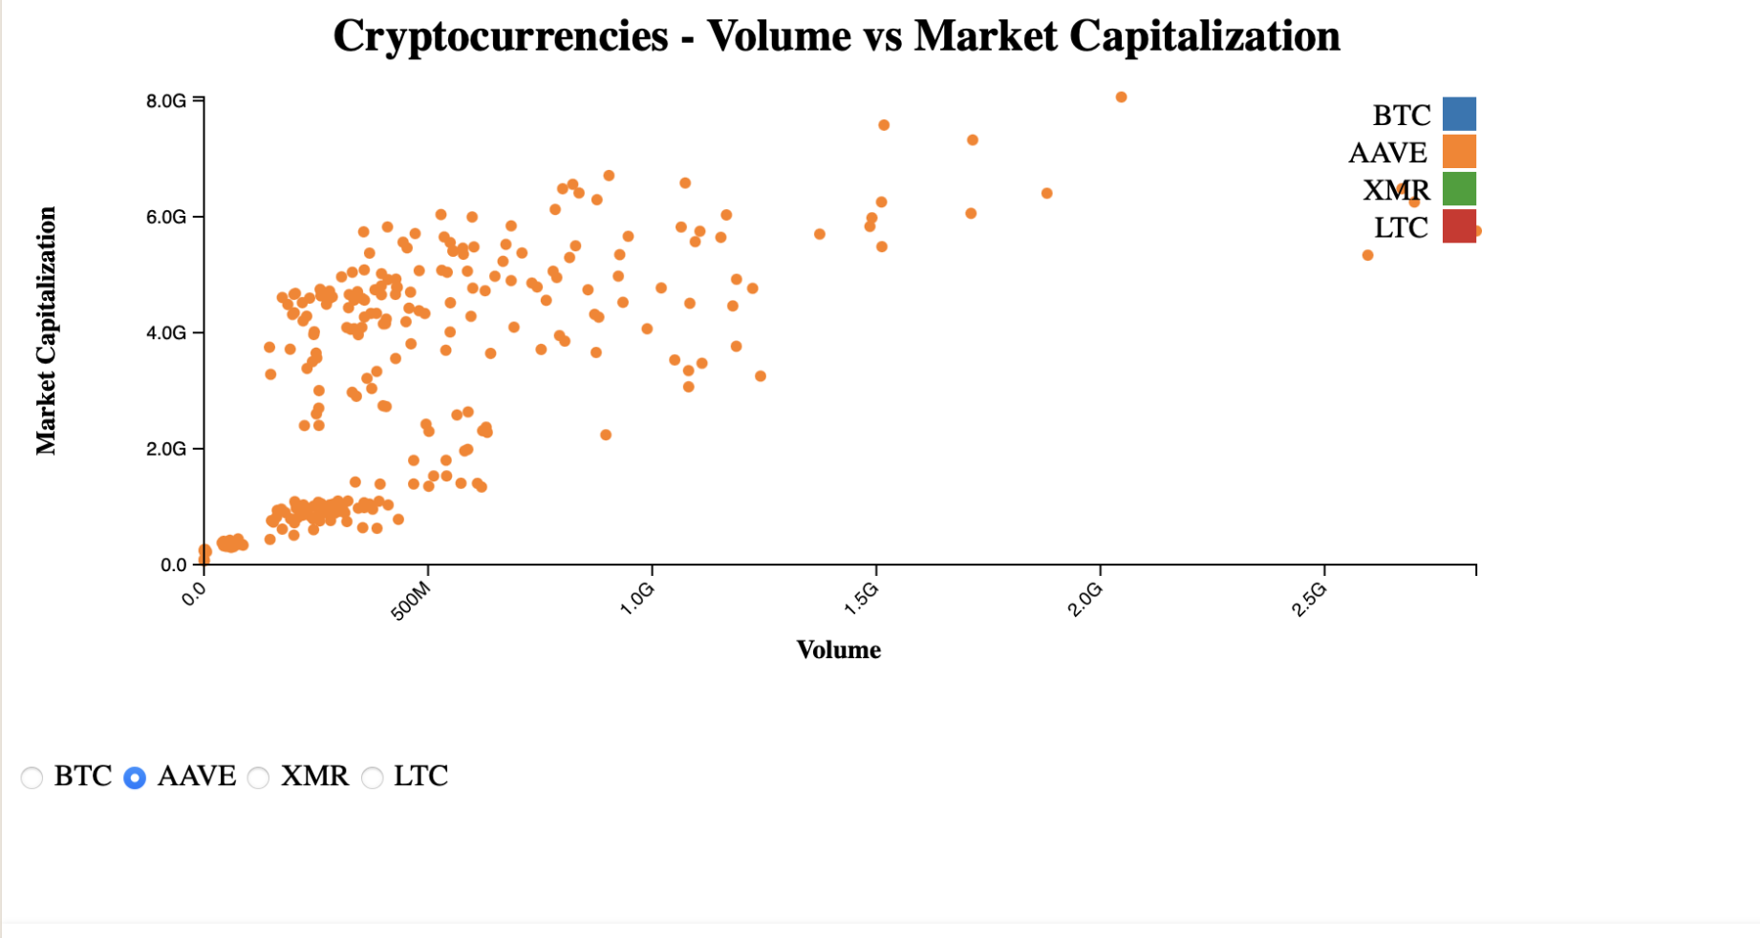

## Fig. 20: Volume vs market Capitalization (AAVE)

Here in the above visualization a scatter plot between the Volume and Market Capitalization which will provide better explanation between the trading activity and the size of asset in the current market. Moreover, this helps in identifying the relations and the patterns that are helpful in making the decision for the investments. The market capitalization is in the Y axis and the Volume is in the X axis , moving further the Market Capitalization is having the highest more that 1.0 T starting from 0 and divided by 200G each and the volume is up to 350G which is divided by 50G per interval. By overserving the above visualization we can conclude that as the volume is increasing the market capitalization also starts increasing. On a whole we can say that this scatter plot will helps in analysing the relation between the Volume and the Market capitalisation for providing the insights that helps in making informed decisions about future investments.

In other words we can say that the volume refers to the total amount that is traded on a platform over a time period and it is normally measured in 24 hour increments, and this can give the details of the cryptocurrency liquidity and the market capitalization means the total value , and the market capitalization is also called market cap in which it refers to the total value of the cryptocurrency.

For AAVE the market capitalization and the volume has been good although it was launched recently the market cap value were good i.e equally distributed. Therefore the investor can conclude take a worthy decision to invest in AAVE.

Vizhub link : https://vizhub.com/senthilrajendran1/b317c29abee04a9cadab2198c19af507

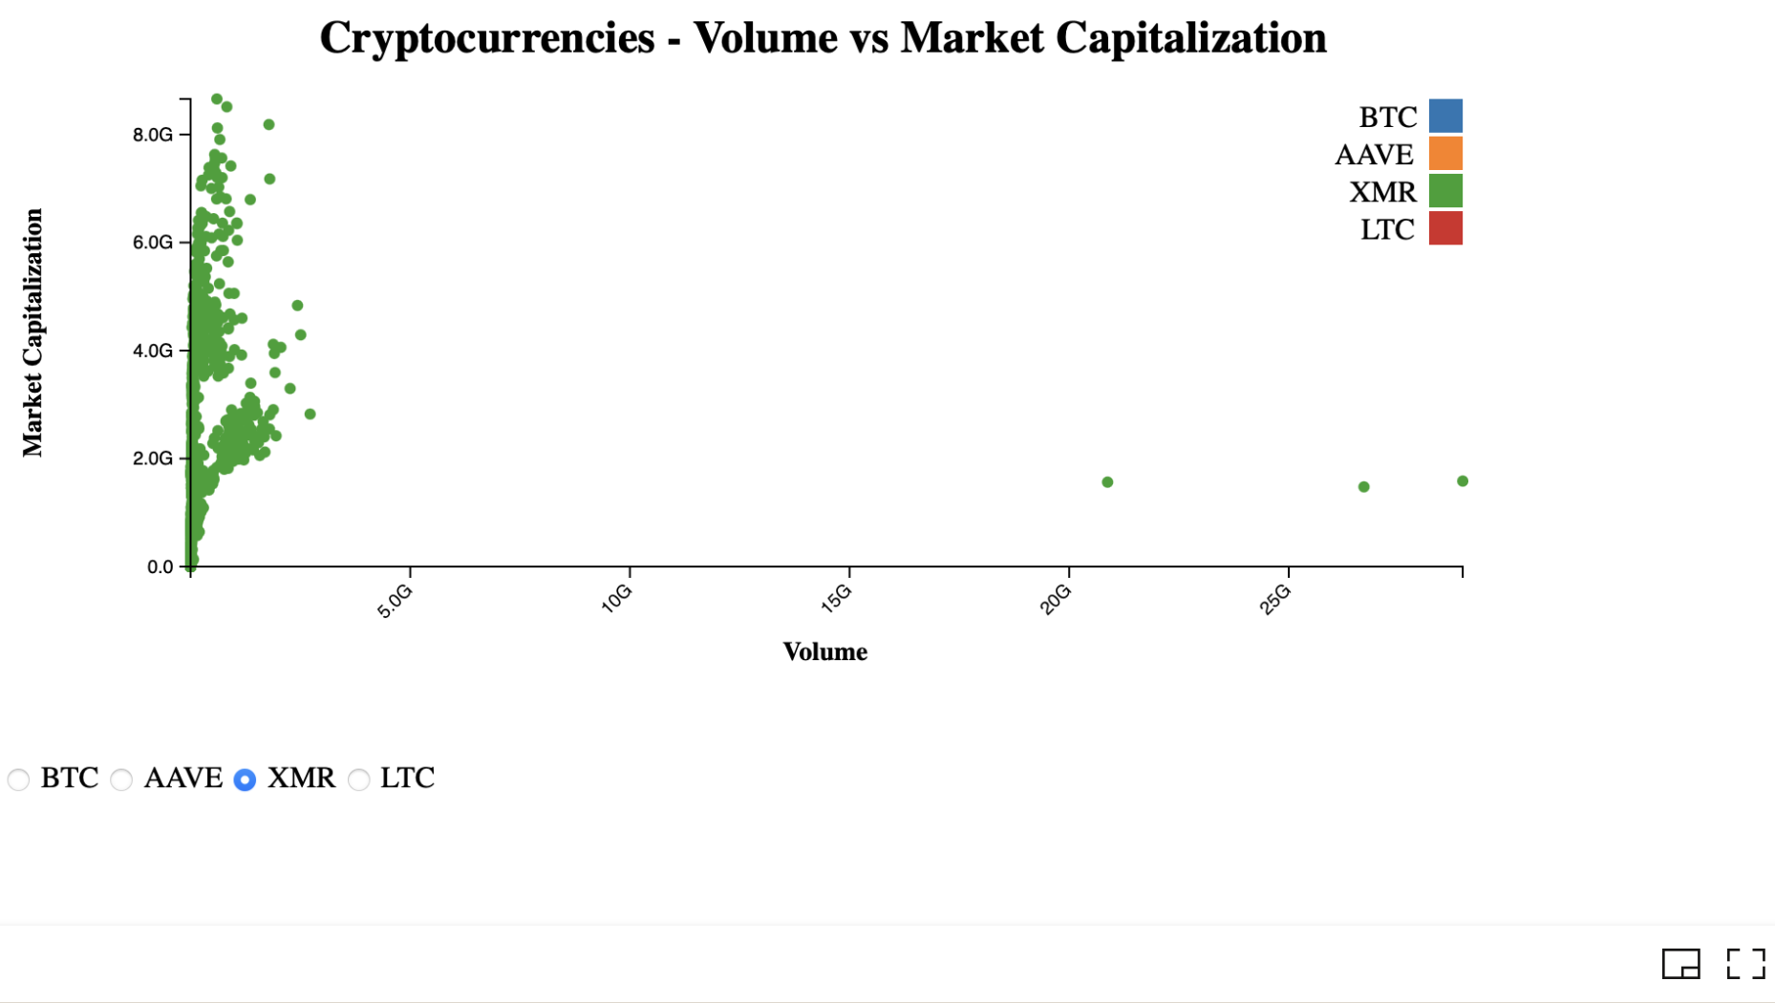

Fig. 21: **Volume vs market Capitalization, (XMR)**

The above scatter plot shows the visualization of the Volume vs market Capitalization for the cryptocurrency XMR which the dots in the scatterplot are displayed in the colour of green and moving further from the plot we can say that the volume is not that much high as much as the AAVE and although we had done about the BITCOIN in the first increment, but the bitcoin is having a higher rate which nearly times more than these currencies. Although the market cap is higher till 8.0 G but the volume is nearly under 5.0 G for this currency and also the if the investor want to take decision about the volume and the market cap for this currency , the decision can be made by this visualization with the better insights about the XMR cryptocurrency.

Vizhub link: <https://vizhub.com/senthilrajendran1/b317c29abee04a9cadab2198c19af507>

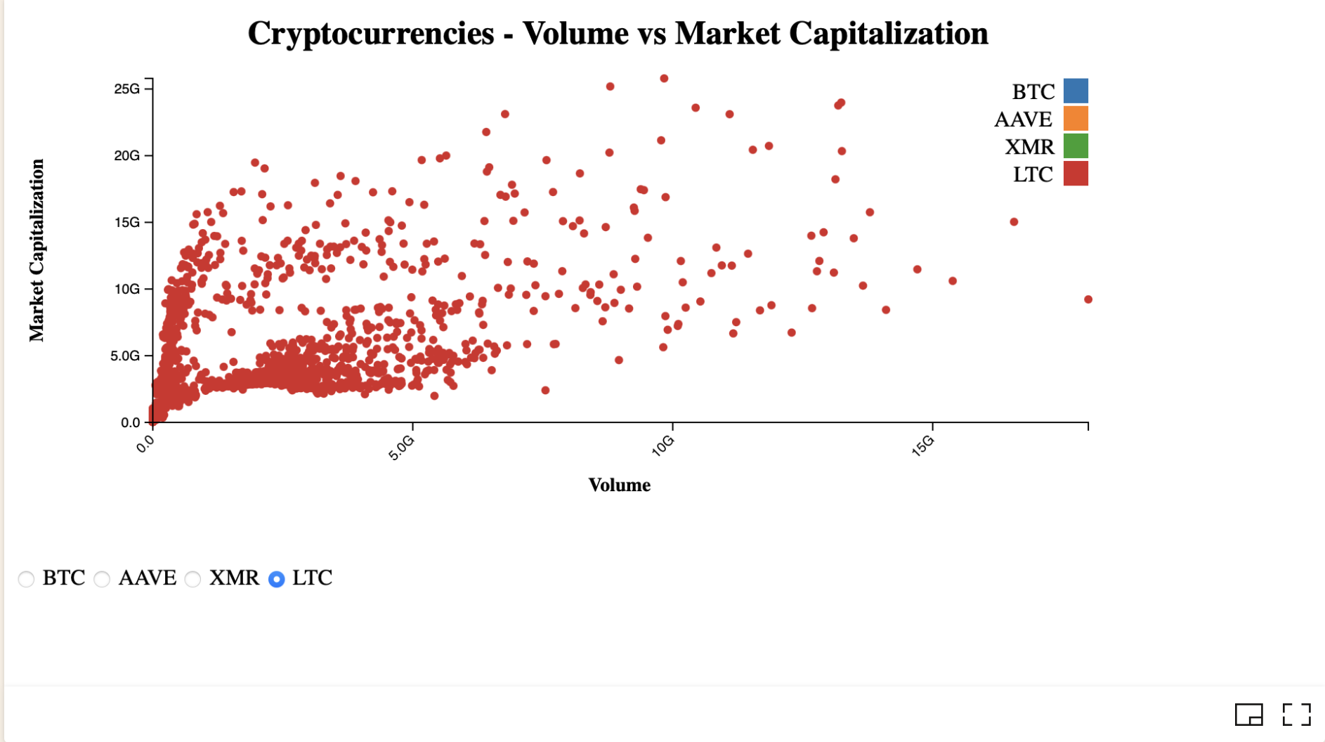

## Fig. 22 : Volume vs market Capitalization(LTC)

The above scatter plot shows the visualization of the Volume vs market Capitalization for the cryptocurrency LTC which the dots in the scatterplot are displayed in the colour of red and moving further from the plot we can say that the volume and the market cap are directly related to each other i.e. the and the values are more within the volume lest than 5.0 G and after the volume has reached more than 5.0 G then the values are less and the decision can be made on volume to select by this insights of the cryptocurrency .

Vizhub link: <https://vizhub.com/senthilrajendran1/b317c29abee04a9cadab2198c19af507>

Task: Percentage Change in Price Over Time, We had discussed about the bitcoin in the Increment 1, here are the visualizations for other cryptocurrencies.

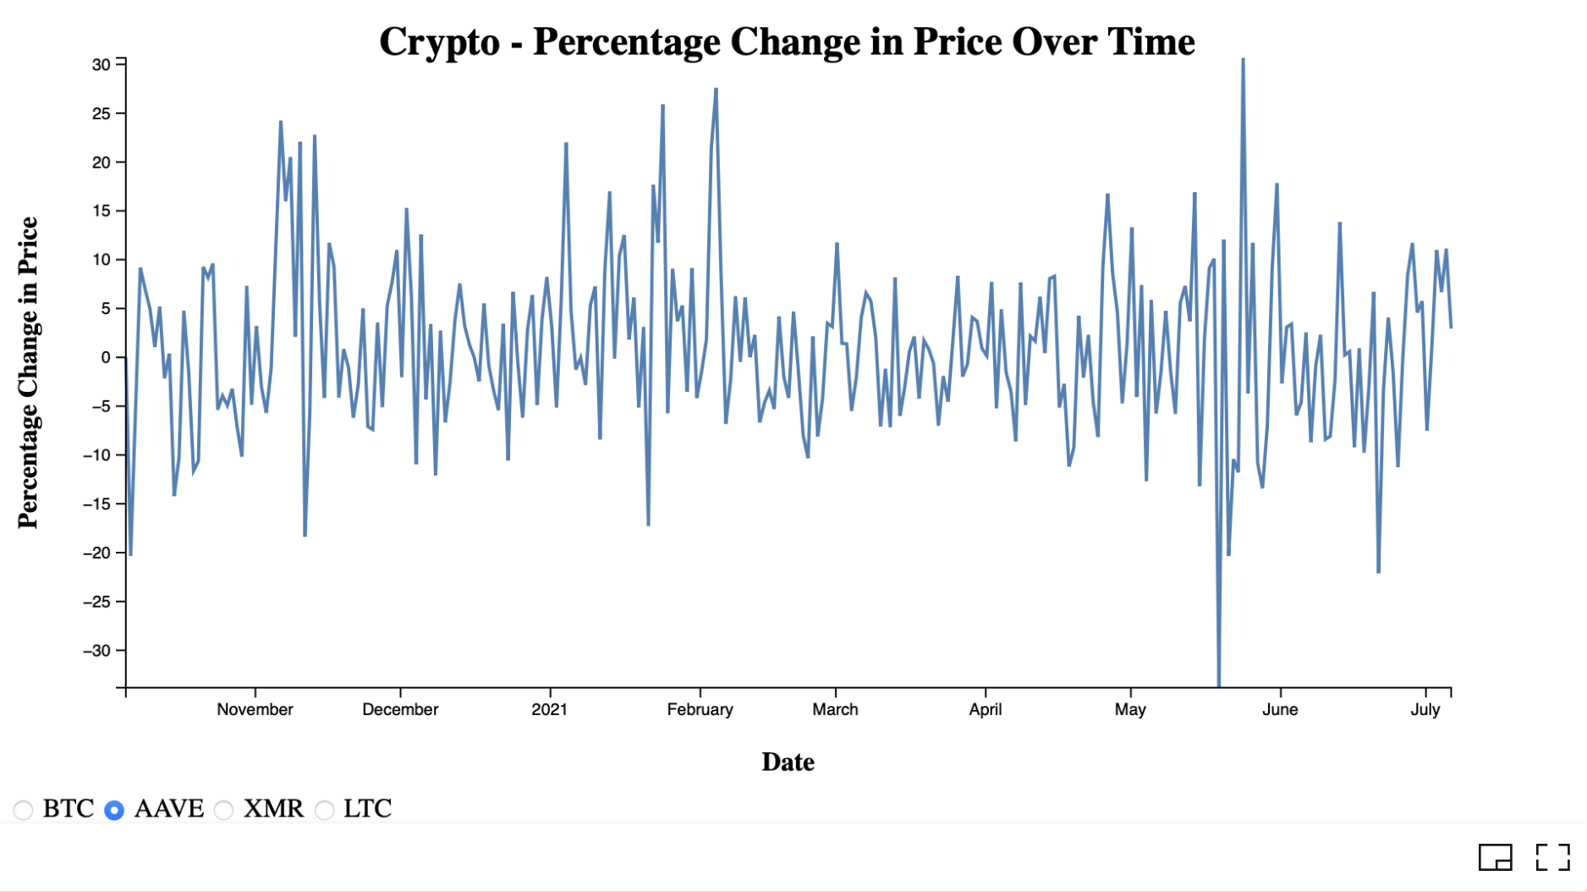

## Fig. 23 : Percentage change in price over time (AAVE)

For AAVE cryptocurrency: The above visualization shows Percentage Change in price over time of the AAVE cryptocurrency, which was recently released in the year of 2020, in the X axis we had date which is divided by months staring from the November of the year 2020 and on the Y axis we had values ranging from -30 to +30.

Visualizing of the chart showing the percentage of change in price over time will provide the better insights of price of the AAVE currency over the months . Moreover, this visualization helps in understanding the market trends and this will also further helps in identifying volatility which means the price swings over periods. We can observe from the graph the price is not always consistent and there are fluctuations for each and every month and there are negative values and the value went down to -30 in the month of the June. So by taking this graph in to consideration the investor can start making decisions on the investments in AAVE.

Vizhub link : <https://vizhub.com/senthilrajendran1/08f6e38cad434547b3e0a02910376f19>

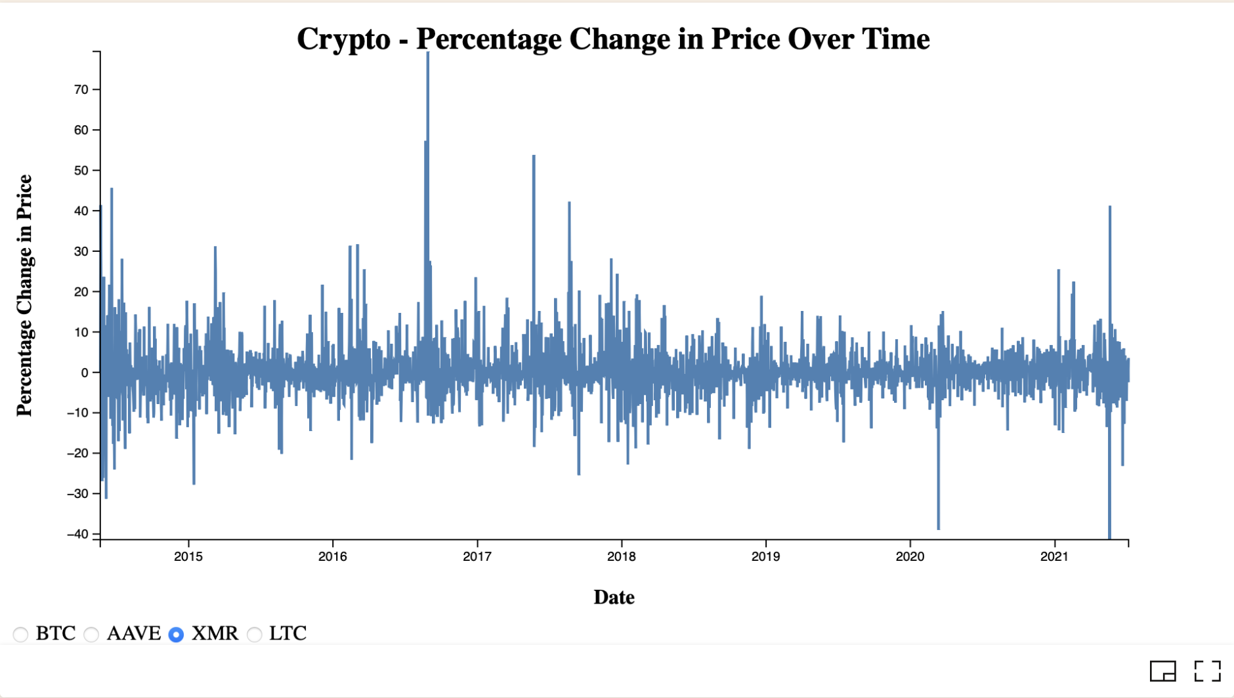

Fig. 24 : Percentage change in price over time (XMR)

For XMR cryptocurrency: The above visualization shows Percentage Change in price over time of the XMR cryptocurrency from the years 2015 to 2021, in the X axis is divided by years from 2015 to 2021 with the intervals per one year from 2015 to 2021 and on the y axis is having a values ranging from -40 to 70.

By analysing the chart we can conclude that the overall percentage of change in price over time which will give better details and insights of the price change. The highest values is the more thant + 70 and the lowest values is -40. The highest value is observed is the year of 2016 and the lowest is observed in the year of 2021. The graph is not having that many fluctuations and the investor can make decisions based on this graph which that the XMR currency is consistent and can invest in this crypto currency.

Vizhub link : <https://vizhub.com/senthilrajendran1/08f6e38cad434547b3e0a02910376f19>

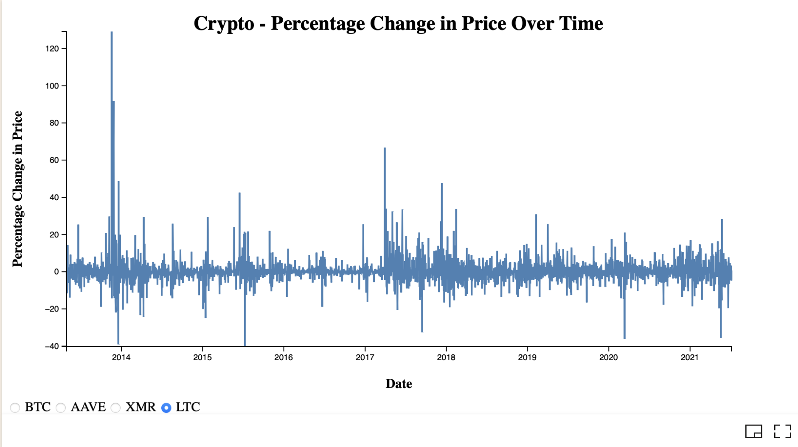

Fig. 25 : Percentage change in price over time (LTC)

The above visualization shows Percentage Change in price over time of the LTC cryptocurrency from the years 2015 to 2021, in the X axis is divided by years from 2015 to 2021 with the intervals per one year from 2015 to 2021 and on the y axis is having a values ranging from -40 to 120.

By analysing the chart we can conclude that the overall percentage of change in price over time which will give better details and insights of the price change. The highest value is the more than 120 and the lowest values is -40. For this cryptocurrency the highest and lowest values are in the same year which in in the year 2014 and there are also some times huge fluctuations in the graph but not all at a time , this will help the investor to make decisions to invest in the LTC in the future based on the graph.

Vizhub link : <https://vizhub.com/senthilrajendran1/08f6e38cad434547b3e0a02910376f19>

Task: Simple Moving Average

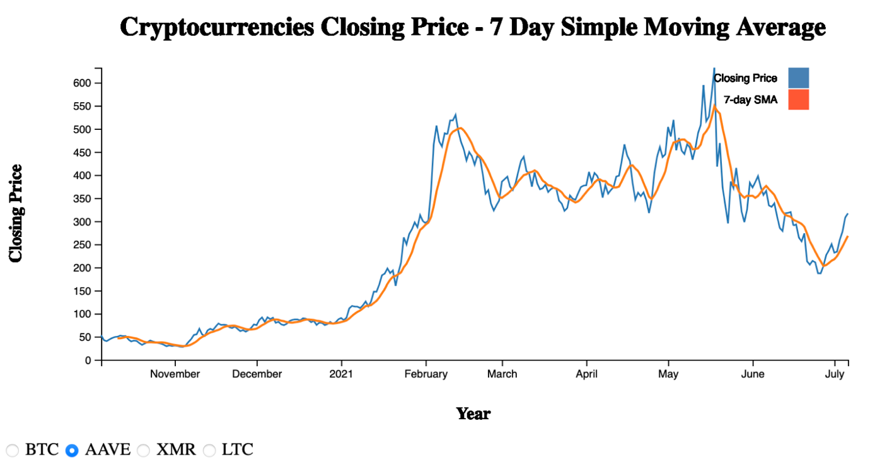

## Fig. 26 : 7 Day Simple Moving Average (AAVE)

The chart displayed depicts the AAVE closing price over a 7-day simple moving average from November 2020 to July 2021. The horizontal X-axis shows the years ranging from November 2020 to July 2021, while the vertical Y-axis displays the price ranging from 0 to 600 with an increment of 50. The blue line indicates the closing price, and the orange line indicates the 7-day simple moving average.

Based on the graph, we can observe that the price of AAVE remained below 100 until December 2020. Afterward, the price began to rise, reaching its peak of 550 in mid-February 2021. The price then began to decline before reaching a new high of over 600 in mid-May, followed by a continued decline until the end of June. However, the price began to rise again in early July 2021.

Vizhub link: <https://vizhub.com/senthilrajendran1/6db98341a9624a04a7b14c26165b362a>

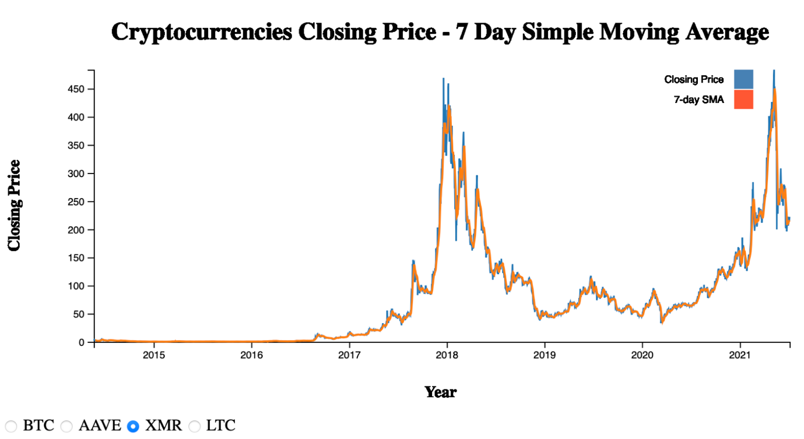

## Fig. 27: 7 Day Simple Moving Average (XMR)

The chart displayed depicts the XMR closing price over a 7-day simple moving average for several years. The horizontal X-axis shows the years ranging from 2015 to 2021, while the vertical Y-axis displays the price ranging from 0 to 450 with an increment of 50. The blue line indicates the closing price, and the orange line indicates the 7-day simple moving average.

The graph depicts the price of XMR, which was below 50 until early 2017. After that, it gradually rose and reached its peak of 450 in early 2018, followed by a decline. Then, at the beginning of 2021, the price started to rise again and surpassed 450 by the end of the year. However, it gradually decreased thereafter.

Vizhub link: <https://vizhub.com/senthilrajendran1/6db98341a9624a04a7b14c26165b362a>

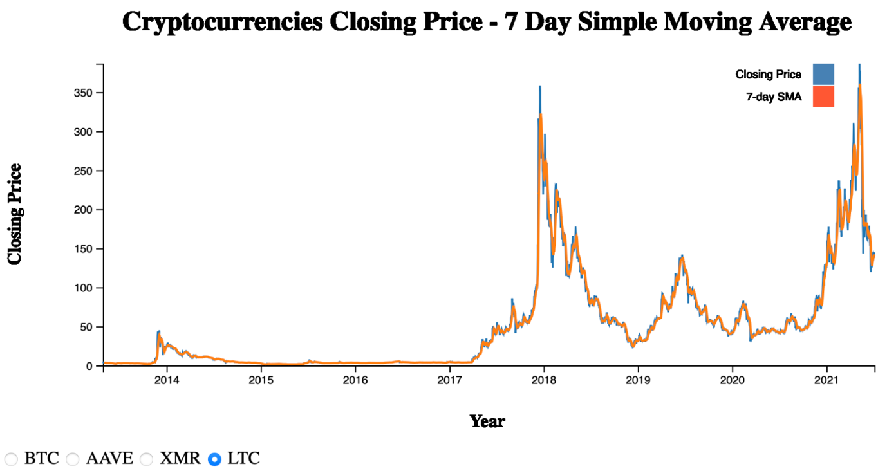

## Fig. 28 : 7 Day Simple Moving Average (LTC)

The chart displayed depicts the LTC closing price over a 7-day simple moving average for several years. The horizontal X-axis shows the years ranging from 2014 to 2021, while the vertical Y-axis displays the price ranging from 0 to 350 with an increment of 50. The blue line indicates the closing price, and the orange line indicates the 7-day simple moving average.

The graph shows that LTC's price was below 50 until the beginning of 2017. The price started to increase from the end of 2017 till reaching its highest price of over 350 at the start of 2018. It then declined till the start of 2019 before starting to rise again by the mid of 2019. The price once again started to decrease till the start of 2020. The price remained between 50 to 100 till the start of 2021 and started to increase eventually reaching over 350 by the end of the year. However, the price then steadily decreased.

Vizhub link: <https://vizhub.com/senthilrajendran1/6db98341a9624a04a7b14c26165b362a>

**Task: 30 Day Simple Moving Average**

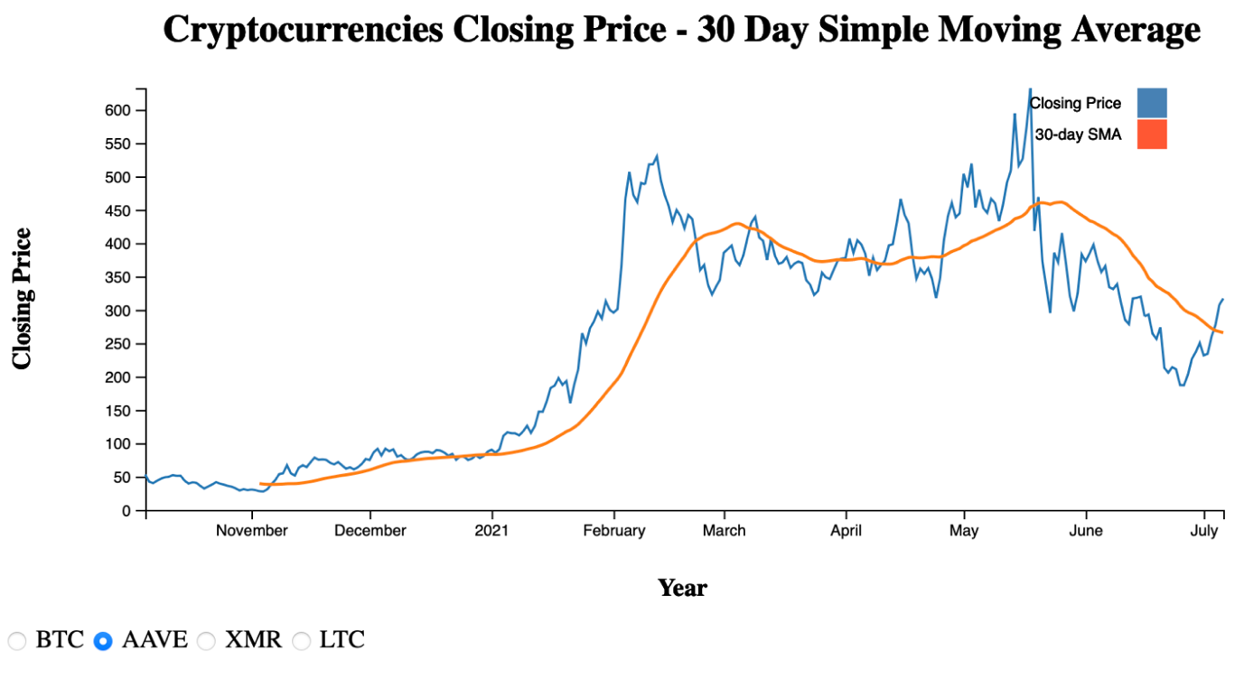

## Fig. 29 : 30 Day Simple Moving Average (AAVE)

The chart displayed depicts the AAVE closing price over a 30-day simple moving average from November 2020 to July 2021. The horizontal X-axis shows the years ranging from November 2020 to July 2021, while the vertical Y-axis displays the price ranging from 0 to 600 with an increment of 50. The blue line indicates the closing price, and the orange line indicates the 7-day simple moving average.

Based on the graph, we can observe that the price of AAVE remained below 100 until December 2020. Afterward, the price began to rise, reaching its peak of 550 in mid-February 2021. The price then began to decline before reaching a new high of over 600 in mid-May, followed by a continued decline until the end of June. However, the price began to rise again in early July 2021. We observe that the closing price and the 30-day simple moving average differ for AAVE over time.

Vizhub link: https://vizhub.com/senthilrajendran1/efbb877580894e9abe790f8b30a94c62

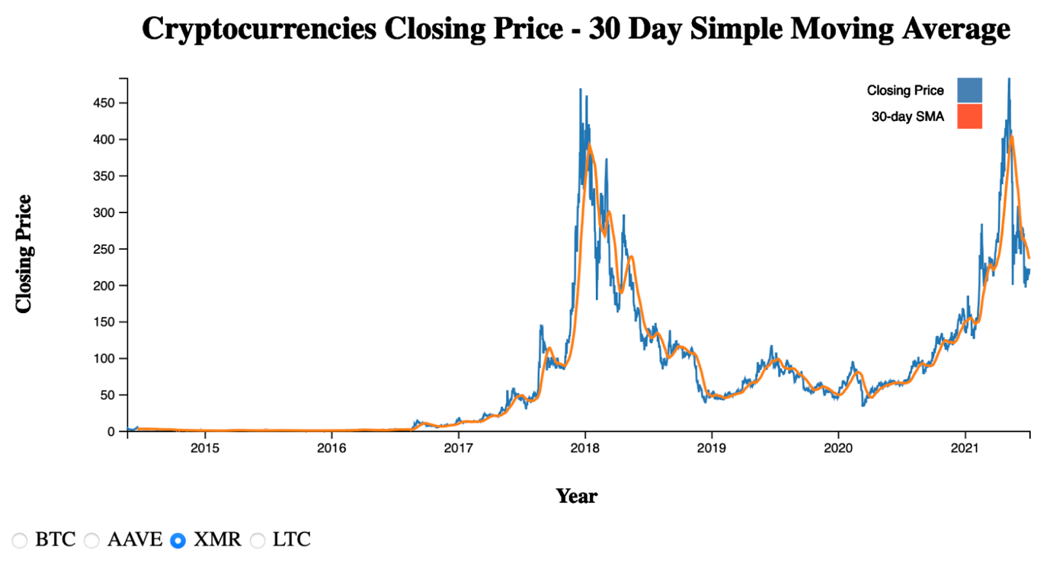

## Fig. 30: 30 Day Simple Moving Average (XMR)

The chart displayed depicts the XMR closing price over a 30-day simple moving average for several years. The horizontal X-axis shows the years ranging from 2015 to 2021, while the vertical Y-axis displays the price ranging from 0 to 450 with an increment of 50. The blue line indicates the closing price, and the orange line indicates the 30-day simple moving average.

The graph depicts the price of XMR, which was below 50 until early 2017. After that, it gradually rose and reached its peak of 450 in early 2018, followed by a decline. Then, at the beginning of 2021, the price started to rise again and surpassed 450 by the end of the year. However, it gradually decreased thereafter.

Vizhub link: <https://vizhub.com/senthilrajendran1/efbb877580894e9abe790f8b30a94c62>

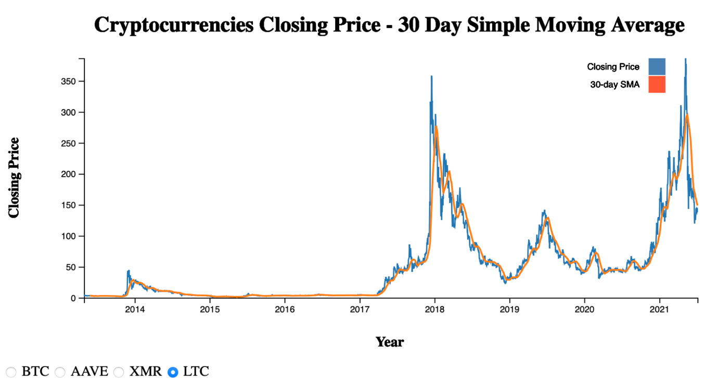

## Fig. 31 : 30 Day Simple Moving Average (LTC)

The chart displayed depicts the LTC closing price over a 30-day simple moving average for several years. The horizontal X-axis shows the years ranging from 2014 to 2021, while the vertical Y-axis displays the price ranging from 0 to 350 with an increment of 50. The blue line indicates the closing price, and the orange line indicates the 30-day simple moving average.

The graph shows that LTC's price was below 50 until the beginning of 2017. The price started to increase from the end of 2017 till reaching its highest price of over 350 at the start of 2018. It then declined till the start of 2019 before starting to rise again by the mid of 2019. The price once again started to decrease till the start of 2020. The price remained between 50 to 100 till the start of 2021 and started to increase eventually reaching over 350 by the end of the year. However, the price then steadily decreased.

Vizhub link: <https://vizhub.com/senthilrajendran1/efbb877580894e9abe790f8b30a94c6>

**Task: 90 Day Simple Moving Average**

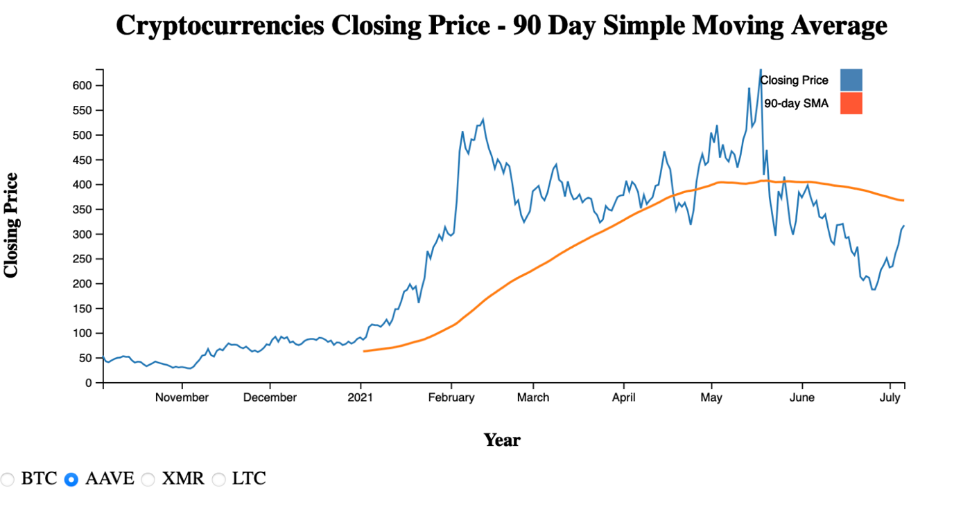

## Fig. 32 : 90 Day Simple Moving Average (AAVE)

The chart displayed depicts the AAVE closing price over a 90-day simple moving average from November 2020 to July 2021. The horizontal X-axis shows the years ranging from November 2020 to July 2021, while the vertical Y-axis displays the price ranging from 0 to 600 with an increment of 50. The blue line indicates the closing price, and the orange line indicates the 90-day simple moving average.

Based on the graph, we can observe that the price of AAVE remained below 100 until December 2020. Afterward, the price began to rise, reaching its peak of 550 in mid-February 2021. The price then began to decline before reaching a new high of over 600 in mid-May, followed by a continued decline until the end of June. However, the price began to rise again in early July 2021. We observe that the closing price and the 90-day simple moving average differ from the start of 2021 for AAVE over time

Vizhub link: https://vizhub.com/senthilrajendran1/cdb45e66b2c04bb7913d3bfbce30c14a

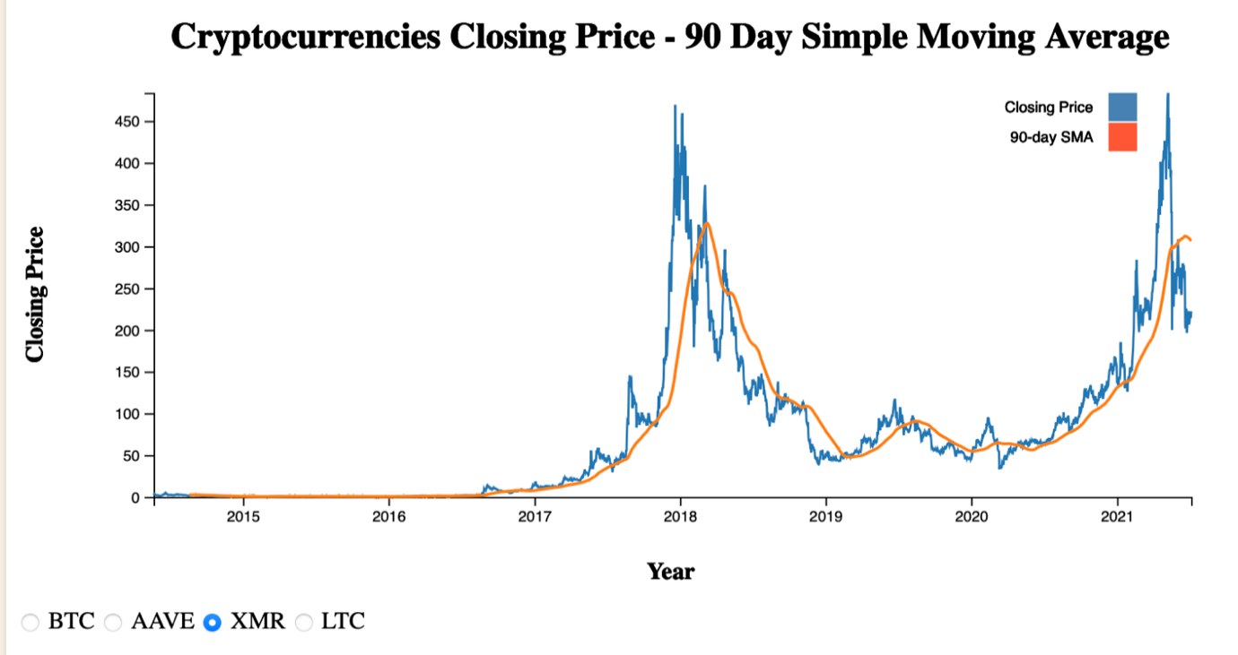

## Fig. 33 : 90 Day Simple Moving Average (XMR)

The chart displayed depicts the XMR closing price over a 90-day simple moving average for several years. The horizontal X-axis shows the years ranging from 2015 to 2021, while the vertical Y-axis displays the price ranging from 0 to 450 with an increment of 50. The blue line indicates the closing price, and the orange line indicates the 90-day simple moving average.

This chart shows how the price of XMR changed over time. At first, it was less than 50, but it slowly increased until it reached a high point of 450 in early 2018. Then, the price went down again. However, it started rising again at the beginning of 2021 and went above 450 by the end of the year. But then it started going down again. We can also see that until the end of 2016, the closing price and the 90-day simple moving average were the same, but after that, they started to differ.

Vizhub link: <https://vizhub.com/senthilrajendran1/cdb45e66b2c04bb7913d3bfbce30c14a>

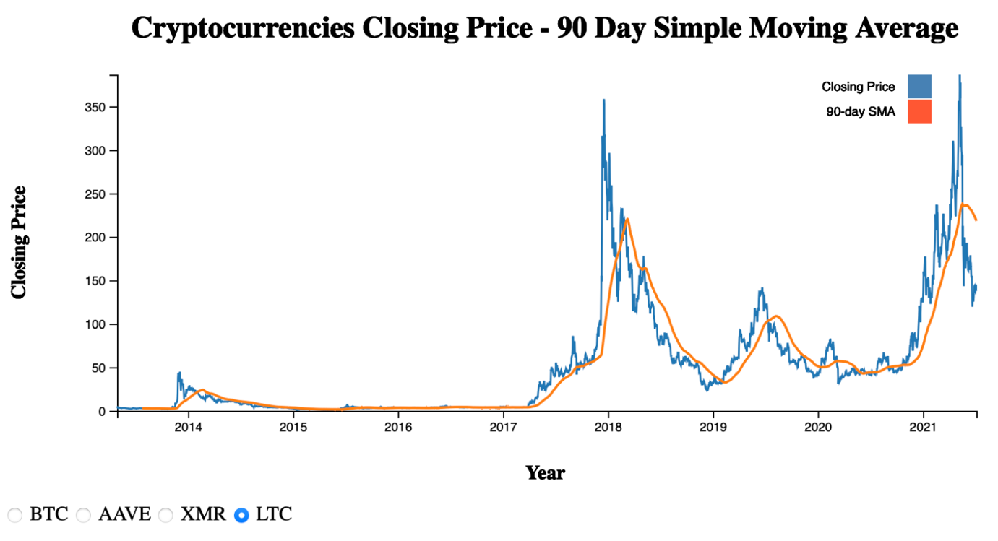

## Fig. 34 : 90 Day Simple Moving Average (LTC)

The chart displayed depicts the LTC closing price over a 90-day simple moving average for several years. The horizontal X-axis shows the years ranging from 2014 to 2021, while the vertical Y-axis displays the price ranging from 0 to 350 with an increment of 50. The blue line indicates the closing price, and the orange line indicates the 90-day simple moving average.

Looking at the graph, we can see that LTC's price remained below 50 until the start of 2017. From the end of 2017, the price began to increase steadily until it reached its highest price of over 350 at the beginning of 2018. However, it then started to decline until the start of 2019, before rising again by mid-2019. Unfortunately, the price decreased once again until the start of 2020, and remained between 50 to 100 until the start of 2021. The price eventually started to increase again, reaching over 350 by the end of the year, but it then steadily decreased once more. If we observe the difference in closing price and the 90-day simple moving average, we can see a noticeable difference during the mid of 2014. After that, the difference between the two is negligible until the mid of 2017. We can once again observe the difference between the two till the end.

Vizhub link: <https://vizhub.com/senthilrajendran1/cdb45e66b2c04bb7913d3bfbce30c14a>

**Task : Daily Price Fluctuations**

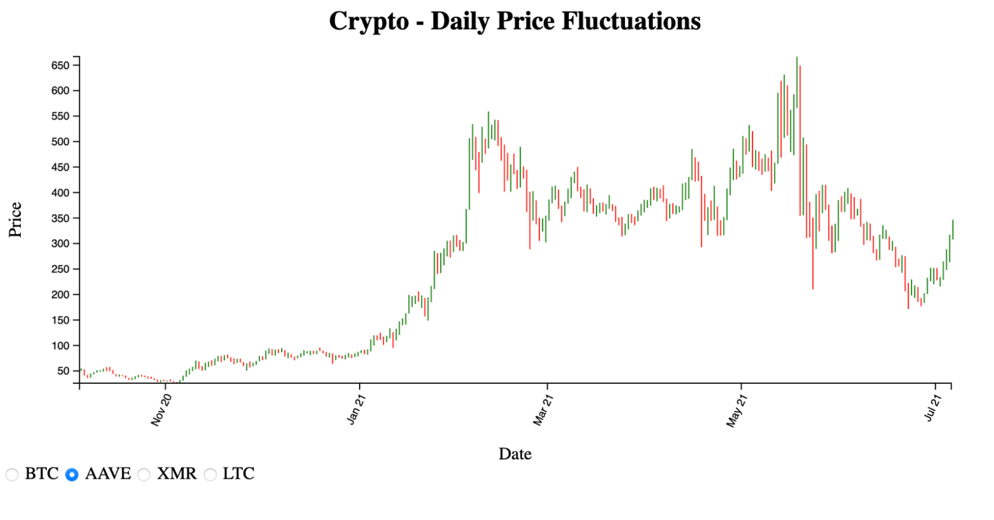

## Fig. 35 : Crypto- Daily Price Fluctuations(AAVE)

The chart displayed depicts the BTC daily price fluctuations from November 2020 to July 2021. The horizontal X-axis shows the years starting from November 2020 to July 2021, while the vertical Y-axis displays the price ranging from 0 to 650 with an increment of 50.

Based on the graph, we can observe that the price of AAVE remained below 100 until January 2021. Afterward, the price began to rise, reaching its peak of above 550 at the end of February 2021. The price then began to decline before reaching a new high of over 650 in June, followed by a continued decline until the start of July. However, the price began to rise again in early July 2021.

Vizhub link: <https://vizhub.com/senthilrajendran1/68ca5a38781d42e3b59233763aae2d84>

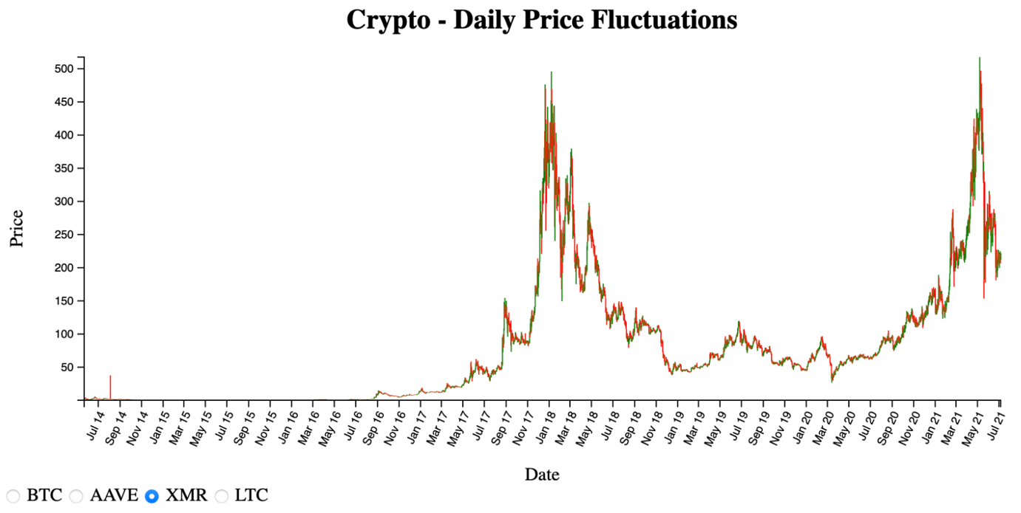

## Fig. 36 : Crypto- Daily Price Fluctuations(XMR)

The chart displayed depicts the XMR daily price fluctuations. The horizontal X-axis shows the years ranging from beginning from July 2014 to July 2021, while the vertical Y-axis displays the price ranging from 0 to 500 with an increment of 50.

The chart displays the fluctuation of XMR's price over time. Initially, it was below 50 until May 2017, but it gradually rose and peaked at 500 in January and February 2018. Afterward, the price decreased but started to climb again in early 2021, surpassing 500 in MAY 2021. Unfortunately, it has recently decreased once again.

Vizhub link: <https://vizhub.com/senthilrajendran1/68ca5a38781d42e3b59233763aae2d84>

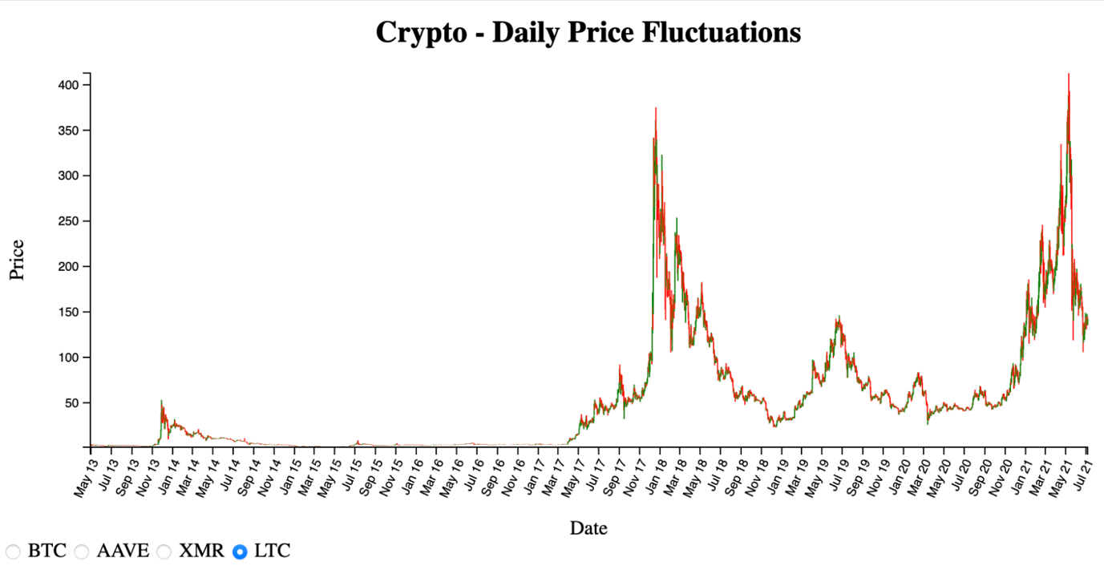

## Fig. 37 : Crypto- Daily Price Fluctuations(LTC)

The chart displayed depicts the daily price fluctuations of LTC. The horizontal X-axis shows the years ranging from May 2013 to July 2021, while the vertical Y-axis displays the price ranging from 0 to 400 with an increment of 50.

Looking at the graph, we can see that LTC's price remained below 50 until November 2013. It reached 50 in December 2013, before falling below 50 at the start of January 2014. It continued to remain under 50 till May 2017. The price began to increase steadily until it reached its highest price of over 350 in January 2018. However, it then started to decline until January 2019, before rising again by July 2019. Unfortunately, the price decreased once again until February 2020 and remained between 50 to 100 until January 2021. The price eventually started to increase again, reaching 400 in May 2021, but it then steadily decreased once more.

Vizhub link: <https://vizhub.com/senthilrajendran1/68ca5a38781d42e3b59233763aae2d84>

**Task: Rolling 30-day correlation between BTC and Other Cryptocurrencies**

Code for this visualization is attached in the source code zip file for your reference.

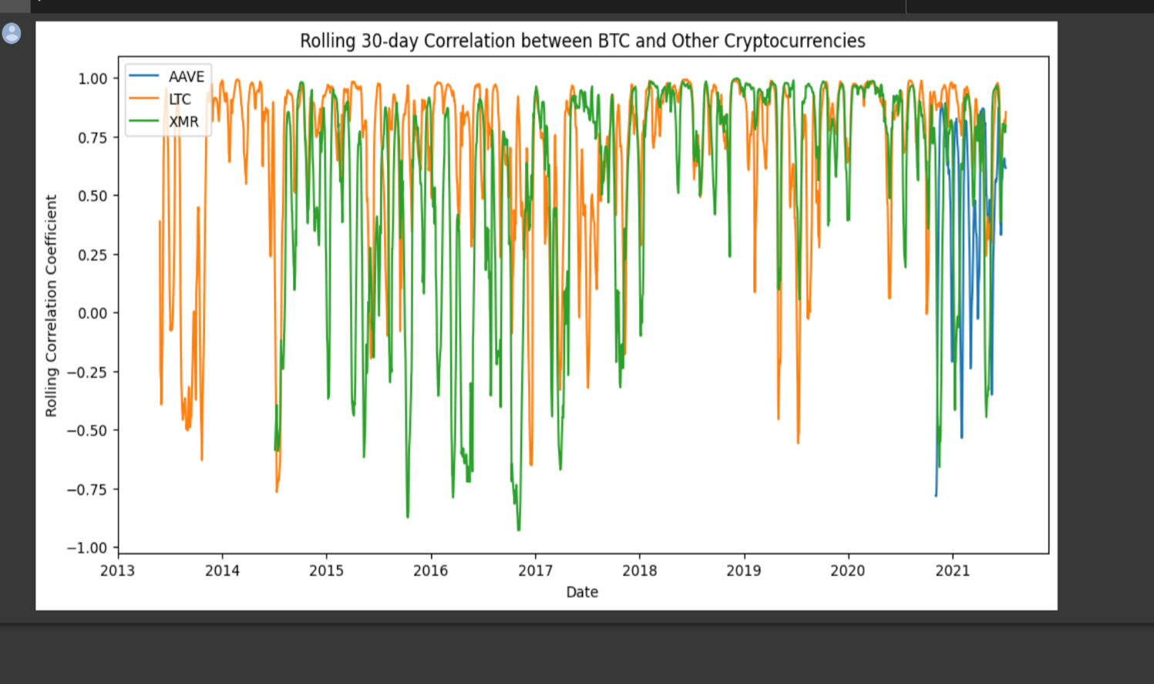

## Fig. 38: Rolling 30 Day correlation between BTC and other Cryptocurrencies

The above visualization will give the insights of the correlation between the bitcoin and the other cryptocurrencies in this example the other are AAVE, LTC,XMR .

AAVE is represented by a blue line from 2020 as it was recently launched in the year 2020.

LTC is represented by a orange line.

XMR is represented by green line.

The x axis contains years from 2013 to 2021 with a regular interval of 1 year each and the y axis contains Rolling correlation coefficient from -1.0 to +1.0 with .25 intervals.

The correlation between them refers to the how closely the price movements of BTC and other cryptocurrencies are related with each other, in simple words we can say that when there is a fluctuation in the price of bitcoin, this visualization will show the fluctuations of the above cryptocurrencies and how they are related. So, the investor can know about the relation between the currencies and can make informed decisions based on these visualizations.

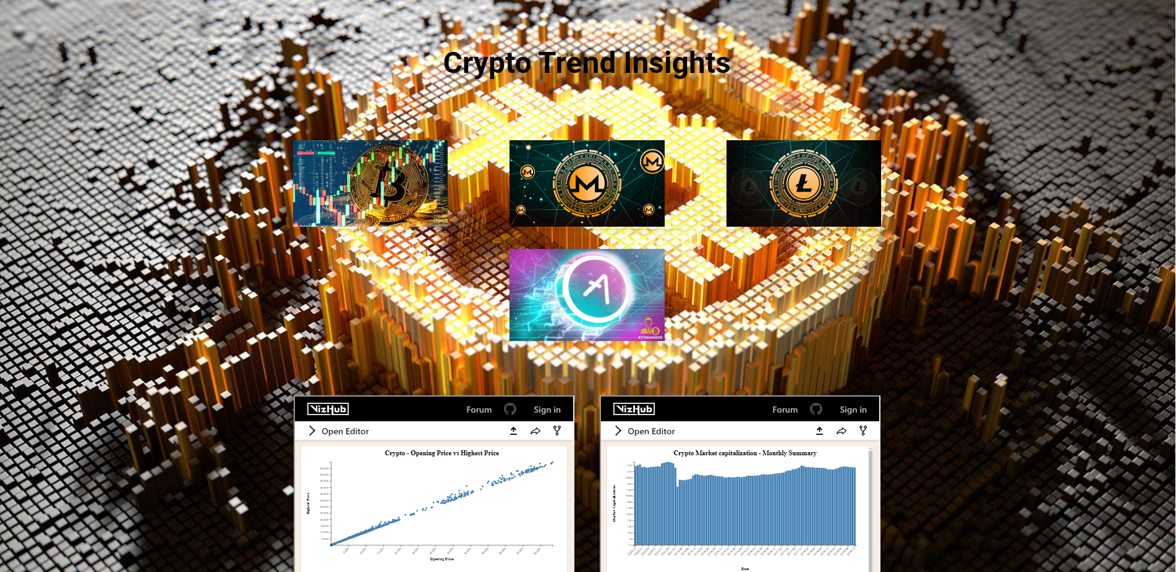

**Fig. 39: Aggregation Webpage with all the visualizations**

PROJECT MANAGEMENT

**IMPLEMENTATION STATUS REPORT:**

**Work completed (Increment 1)**

* **Description**

The main goal of this project is to analyse the trends in the cryptocurrenct . We are collecting cryptocurrency information using th dataset . By using that information we are visualizing the data. Since Crypto currency is a time based information we have completed implementing Line charts, Scatter plots & Bar charts. The visualizations are created and then posted in the webpage so that the user can observe the changes.

* **Contributions (members)**

|  |  |  |
| --- | --- | --- |
| **NAME** | **CONTRIBUTIONS** | |
|  | REPORT | IMPLEMENTATION |
| Dowtya Sri Prasanth Vemula | Goals & Objectives,  Implementation using tools | BTC - Closing Price, Daily Price Fluctuations &  Percentage Change in Price Over time Reports |
| Lakshmi Priya Kalapala | Domain, Data Abstraction, work to be completed | BTC – Volume Vs Market Cap, Opening Price Vs Highest Price Reports |
| Senthil Kumar Rajendran | Task Abstraction,  Implementation using tools, References | SMA 7/30/90 Day Reports |
| ViswakSenaPalaparthi | Preliminary results of analysis,  Project Management | BTC Market Capitalisation – Country & Monthly Summary Reports |

**Work completed (Increment 2)**

* **Description**

For the increment 2 we are going to cover the visualization using the D3.js, Altar & Python and adding more visualizations for more cryptocurrencies. Further we are going to modify and develop the web page by adding some features and the components with more visualizations.

* **Responsibility (task, Person)**

|  |  |
| --- | --- |
| **NAME** | **TASK** |
| Dowtya Sri Prasanth Vemula | Multi Cryptocurrencies - Price, Daily Price Fluctuations &  Percentage Change in Price Over time Reports |
| Lakshmi Priya Kalapala | Multi Cryptocurrencies – Volume Vs Market Cap, Opening Price Vs Highest Price Reports |
| Senthil Kumar Rajendran | Multi Cryptocurrencies - SMA 7/30/90 Day Reports, Correlation b/w currencies. |
| ViswakSenaPalaparthi | Multi Cryptocurrencies - Market Capitalisation – Country & Monthly Summary Reports |

# 

# REFERENCE / BIBLIOGRAPHY

1. Cryptocurrency Historical Prices - Prices of top cryptocurrencies including BTC, ETH, ADA, DOT and BNB
   * 1. <https://www.kaggle.com/datasets/sudalairajkumar/cryptocurrencypricehistory>
2. Lisa, Andrew. “7 Of the Biggest Bitcoin Crashes in History.” *GOBankingRates*, GOBankingRates, 30 June 2021,
   * 1. [https://www.gobankingrates.com/investing/crypto/7-biggest-bitcoin-crashes-history/](https://www.gobankingrates.com/investing/crypto/7-biggest-bitcoin-crashes-history/./) ● Investor, Gasebu Private. “The Crypto Bubble and Inflation
     2. (Cryptocurrency:BTC-USD).” *SeekingAlpha*, Seeking Alpha, 25 Dec. 2020, <https://seekingalpha.com/article/4396069-crypto-bubble-and-inflation>
3. “Dogecoin: Analysis of Meme Cryptocurrency Data Using Python.” *Analytics Vidhya*, 31 May 2021,
   * 1. [https://www.analyticsvidhya.com/blog/2021/05/dogecoin-analyze-meme-cryptocurrencydata-using-python/](https://www.analyticsvidhya.com/blog/2021/05/dogecoin-analyze-meme-cryptocurrency-data-using-python/)

## Images References

* [https://blog.streetshares.com/hs-fs/hubfs/cryptocurrency-fb.jpg?width=1200&name=cryp tocurrency-fb.jpg](https://blog.streetshares.com/hs-fs/hubfs/cryptocurrency-fb.jpg?width=1200&name=cryptocurrency-fb.jpg)
* <https://i.ya-webdesign.com/images/crypto-coins-png>